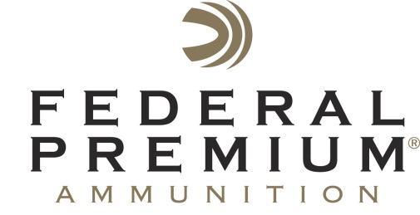
Contact: JJ Reich
Public Relations Specialist
763-323-3862
FOR IMMEDIATE RELEASE E-mail: pressroom@atk.com

Federal Premium Announces International Hunter Education Association Volunteer Instructor of the Year

Federal Premium® Ammunition is honored to announce Floyd Grass, of Denver, North Carolina, is the recipient of the International Hunter Education Association (IHEA-USA) Volunteer Instructor of the Year award. He will be honored June 3 during the 2014 IHEA-USA Annual Conference in Charleston, South Carolina.

ANOKA, Minn. – May 28, 2014 – Federal Premium® Ammunition is proud to announce the International Hunter Education Association (IHEA-USA) Volunteer Instructor of the Year. Floyd “Link” Grass, of Denver, North Carolina, is this year’s recipient. He will receive the award June 3 during the 2014 IHEA-USA Annual Conference in Charleston, South Carolina.

Grass is one of more than 55,000 IHEA-USA instructors who reach more than 650,000 hunter education students annually. He exemplifies the strength of IHEA-USA’s mission in the U.S. and internationally: To continue the heritage of hunting worldwide by developing safe, responsible and knowledgeable hunters.

Grass has been an active member in the North Carolina hunter education program for more than 15 years. In 2013, he organized and taught 56 hunter education courses that certified 811 students. He also recruited 11 additional volunteer instructors. Grass has received multiple “Instructor of the Year” awards at the state and local level, and has been recognized for special achievement and dedication to North Carolina’s hunter education programs.

An IHEA-USA selection committee selected finalists, and a panel of knowledgeable judges named Grass the 2014 award winner. Travis Casper, Hunter Education Coordinator for the North Carolina Wildlife Resources Commission, nominated Grass for, among many accolades, his “exceptional willingness to move forward and promote web-based training and certification opportunities.”

Partnership in Education
Federal Premium has sponsored the IHEA-USA for more than a decade.

“Volunteer instructors have always been the lifeblood of hunter education,” said Ryan Bronson, Federal Premium Conservation Senior Manager. “We sponsor the Instructor of the Year award as a way of recognizing the hunters and shooters who donate their time to pass on our heritage. Hunting and shooting are safe—and getting safer each year—in large part because of dedicated instructors such as Link Grass.”

Federal Premium supports numerous conservation organizations, participates in many ammunition royalty programs, and provides a variety of shooting sports educational materials. To learn more about Federal’s support, please visit: http://www.federalpremium.com/education.

For more on Federal Premium and its full line of products, visit www.federalpremium.com.

For more on IHEA-USA and to learn how you can help support the future of hunting and hunter education, visit www.ihea.com.

###

