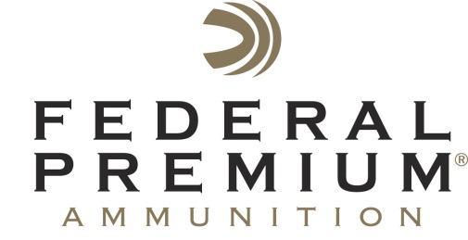
Contact: JJ Reich
Communications Manager
Shooting Sports
763-323-3862
FOR IMMEDIATE RELEASE E-mail: Vistapressroom@vistaoutdoor.com

Federal Premium Launches Win-A-Hunt with Chad Belding, Star of “The Fowl Life”

ANOKA, Minnesota – August 31, 2015 – Federal Premium® Ammunition has launched a nationwide sweepstakes in which one lucky person will win a two-day, three-night Kansas waterfowl hunt with Chad Belding, star of “The Fowl Life” outdoor television show, and special guest country music artist Drake White.

Belding is a passionate waterfowl hunter and a champion duck caller. The sweepstakes winner will get to experience his exceptional waterfowl hunting skills first hand and learn the role Federal Premium Black Cloud® loads play in his hunts.

White is a rising country music star and was recently tagged by Billboard Magazine and Rolling Stone as one of the top 10 country artists to watch. His current single “It Feels Good” is on its way up the charts now. He is an avid outdoorsman and is often found in the field or on the water when not on tour.

“This is more than the hunt of a lifetime,” said Federal Premium Product Director Rick Stoeckel. “It’s the opportunity to hunt with a true waterfowl authority, and to experience the deadly performance of Black Cloud ammunition in an amazing setting.”

Sweepstakes dates are August 31, 2015 through October 23, 2015; open to U.S. residents only; must be 21 years or older to enter; one entry per person for the duration of the sweepstakes; no purchase necessary to enter. Hunt to take place Dec. 27-30, 2015.

Get full details on the sweepstakes rules and conditions, and learn how to enter at https://a.pgtb.me/MPmqS6.

The first-place sweepstakes winner will also receive a new 12-gauge Benelli® shotgun and clothing from Federal Premium, “The Fowl Life” and Banded®. A second-place winner will receive a signed guitar from Drake White, clothing from Federal Premium Ammunition, “The Fowl Life” and Banded, and samples of Lucky® beef jerky.

Federal Premium is a brand of Vista Outdoor Inc., an outdoor sports and recreation company. For more information on Federal Premium, go to www.federalpremium.com.

About Vista Outdoor Inc.
Vista Outdoor is a leading global designer, manufacturer and marketer in the growing outdoor sports and recreation markets. The company operates in two segments, Shooting Sports and Outdoor Products, and has more than 30 well-recognized brands that provide consumers with a range of performance-driven, high-quality and innovative products in the ammunition, firearms and outdoor accessories categories. Vista Outdoor products are sold at leading retailers and distributors across North America and worldwide. Vista Outdoor is headquartered in Utah and has manufacturing operations and facilities in 10 U.S. States, Puerto Rico, Mexico and Canada along with international sales and sourcing operations in Canada, Europe, Australia, New Zealand and Asia. For news and information visit www.vistaoutdoor.com or follow us on Twitter @VistaOutdoorInc and Facebook at www.facebook.com/vistaoutdoor.

###

