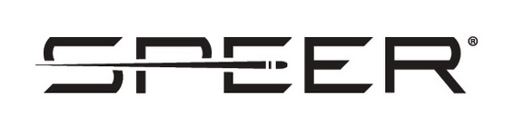

Contact: JJ Reich
Communications Manager
Firearms and Ammunition
(763) 323-3862
E-mail: pressroom@vistaoutdoor.com

FOR IMMEDIATE RELEASE
August 14 2019

Los Angeles Police Department Selects Gold Dot G2 and Force on Force™ As Approved Duty and Training Ammunition

Lewiston, Idaho – The Los Angeles Police Department (LAPD) has recently selected Speer G2 ammunition as the approved duty round in 9mm Luger and 40 S&W and supplying Force on Force marking rounds for training. The contract, with up to seven (7) option years will begin delivery immediately, with the LAPD servicing the department through regional distribution.

“Speer is the number one choice of law enforcement professionals, serving more than eighty percent of law enforcement agencies nationwide” said Jason Vanderbrink, president of Speer. “When it comes to dependability and terminal ballistics, Speer is the gold standard.”

Speer Gold Dot G2 offers the ultimate performance in duty ammunition, thanks to an exclusive nose design. Instead of a large hollow-point cavity, Gold Dot G2 has a shallow dish filled with a high-performance elastomer. On impact, the material is forced into engineered internal fissures to start the expansion process. The result is extremely uniform expansion, better separation of the petals, and more consistent penetration across barrier types through duty handguns.
“When it comes to performance testing, we are putting the most dependable and trusted round on the market for law enforcement, which is the gold standard of bullet terminal performance,” said Handgun Engineering Director Larry Head.
Force on Force™ marker rounds boast superior performance, signature marking and reliable function. Unlike other products on the market, Force on Force training ammunition is lead-free and safe for indoor use. Our special marking agent has an extended shelf-life and leaves a distinctive machine washable mark on target, with lead-free priming making it safe for indoor use
The LAPD is an organization of approximately 13,000 sworn and civilian employees. The City of Los Angeles is 468 square miles operating the third-largest municipal police department in the United States which serves an estimated population of over 4 million people.
Speer Ammunition - is a brand of Vista Outdoor Inc., an outdoor sports and recreation company. For more information on Speer ammunition, go to www.speer-ammo.com

End of Press Release

