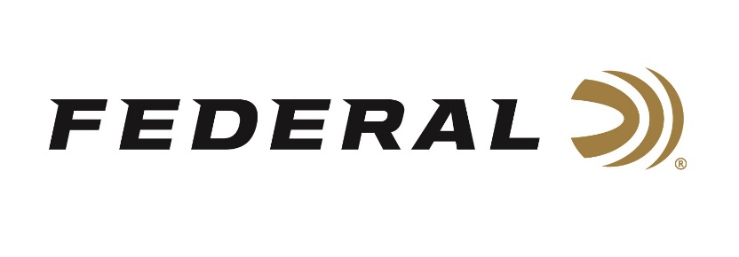
Contact: JJ Reich
Communications Manager
Firearms and Ammunition
(763) 323-3862
E-mail:pressroom@vistaoutdoor.com
FOR IMMEDIATE RELEASE
Federal Ammunition Receives Five Year, $41 Million Ammunition Contract for United States Navy
ANOKA, Minnesota – December 12, 2018 - Federal Ammunition was recently awarded a significant contract from U.S. Naval Surface Warfare Center, Crane Division (NSWC), for MK 318 Mod 0 carbine small rifle cartridges. The five (5) year Indefinite Delivery Indefinite Quantity (IDIQ) contract, is valued at $41 million, and will begin shipping early in 2019, to be utilized by Navy and Marine Corps units.
The MK 318 Mod 0 cartridge, Caliber 5.56mm Ball, Carbine, Barrier is compatible with existing 5.56mm weapons systems and utilizes Federal’s unique barrier defeating projectile. The 62 grain open tip match, lead free projectile is designed to defeat intermediate barriers while providing terminal performance through barriers commonly encountered during warfare, like auto windshields and doors.
“This contract demonstrates the design and production strengths within our business, achieving our goals of meeting customer requirements,” said Federal Ammunition President Jason Vanderbrink. “We are enthused Federal ammunition will continue to serve Navy and Marine Corps units, and their unique needs in combat. Design parameters and development of the projectile, a joint effort between Federal and NSWC, represent the continued innovation, and excellence required to support our units in the field.”
Headquartered in Anoka, Minnesota, Federal ammunition has been providing shooters with high-quality rimfire, centerfire and shotshell ammunition since 1922. It pioneered the Premium category of ammunition and is a world-leading ammunition manufacturer.
The NSWC cohesively and seamlessly operates the Navy's full spectrum research, development, test and evaluation, engineering, and fleet support centers for offensive and defensive systems associated with surface warfare and related areas of joint, homeland and national defense systems from the sea.
Federal Ammunition - is a brand of Vista Outdoor Inc., an outdoor sports and recreation company. For more information on Federal ammunition, go to federalpremium.com .
###

