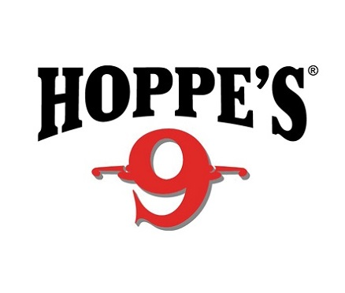
Contact: Jake Edson
Communications Manager
Outdoor Products
(763) 323-3865
FOR IMMEDIATE RELEASE E-mail: pressroom@vistaoutdoor.com

Bushnell and Hoppe’s Pro Maggie Reese Wins USPSA MultiGun National

Maggie Reese Takes Fourth Ladies National Champion Title

OVERLAND PARK, Kansas – April 26, 2017 – Team Bushnell Tactical Shooter and Hoppe’s Pro Maggie Reese took home the 2017 Ladies National Champion in Open Division at the U.S. Practical Shooting Association MultiGun Nationals in Boulder City, Nevada. It was her fourth Ladies National Champion Title, following wins in 2009, 2010 and 2015.

The competition drew about 270 competitors to compete in rifle, shotgun, and handgun over 13 stages. Reese competed in the Open Division, which allows the use of multiple optics and bipods with no limit on magazine capacity.

“I used my Bushnell Elite Tactical SMRS 1-6.5x24mm as my primary optic,” Reese said. “It’s No. 1 for clarity and durability. I also used the Bushnell First Strike Red Dot as my secondary optic on the rifle, as well as on my pistol and shotgun.”

Reese credits practice and preparation for her success. Even in the hot, dry conditions of the Nevada desert, her guns never let her down.

“To prep and clean my guns I used the Hoppe’s Black line which is perfect for the high round count stages in MultiGun as well as the hot Las Vegas temperatures,” Reese said.

Reese is well-known for appearances on the History Channel’s “Top Shot!” Season 2 cast, Sportsman Channel’s “3-Gun Nation” and “Modern Shooter,” and Outdoor Channel’s “Shooting USA.” She is now a four-time USPSA MultiGun National Champion and has won multiple Ladies 3-Gun champions titles at Superstition Mountain Mystery, MGM Ironman and Rocky Mountain 3-Gun. Up next, she will appear in the Vista Outdoor booth at the 2017 NRA Annual Meetings and Exhibits Show. Reese will present a gun-care product demonstration from 3-3:30 p.m. on Friday, April 28 in the Hoppe’s area and will join a special “Women of Vista” question-and-answer session from 4-5 p.m. on Saturday, April 29.

Bushnell and Hoppe’s are both brands of Vista Outdoor. For more information on Bushnell, one of the most recognizable and trusted names in precision hunting, tactical and recreational optics, visit www.bushnell.com.

Hoppe’s has earned the reputation as “The Gun Care People” for more than 100 years. For more information on their innovative new line of cleaners visit www.hoppes.com/black.

About Vista Outdoor
Vista Outdoor is a leading global designer, manufacturer and marketer of consumer products in the growing outdoor sports and recreation markets. The company operates in two segments, Shooting Sports and Outdoor Products, and has a portfolio of well-recognized brands that provides consumers with a wide range of performance-driven, high-quality and innovative products for individual outdoor recreational pursuits. Vista Outdoor products are sold at leading retailers and distributors across North America and worldwide. Vista Outdoor is headquartered in Utah and has manufacturing operations and facilities in 13 U.S. States, Canada, Mexico and Puerto Rico along with international customer service, sales and sourcing operations in Asia, Australia, Canada, Europe and New Zealand. For news and information, visit www.vistaoutdoor.com or follow us on Twitter @VistaOutdoorInc and Facebook at www.facebook.com/vistaoutdoor.
###

