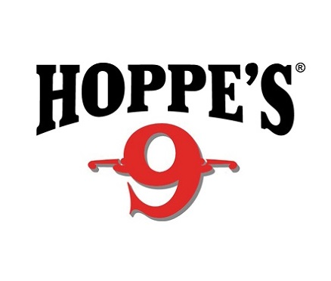
Contact: Jake Edson
Communications Manager
Outdoor Products
(763) 323-3865
FOR IMMEDIATE RELEASE E-mail: pressroom@vistaoutdoor.com

Bushnell and Hoppe’s Pro Maggie Reese Wins Superstition Mountain Mystery 3-Gun Match

Reese Takes Lady Open Division in One of the Longest Running 3-Gun Matches in the Country

OVERLAND PARK, Kansas – March 31, 2017 – Team Bushnell Tactical Shooter and Hoppe’s Pro Maggie Reese won High Lady in the Open Division at the 2017 Superstition Mountain Mystery 3-Gun Match in Mesa, Arizona.

Held March 24 to 26 at the Usery Mountain Shooting Range in Mesa, the Superstition Mountain Mystery 3-gun Match is one of the longest-running 3-gun matches in the country. Reese, a three-time National Champion in USPSA Multi-Gun, had previously won the event in 2009, 2010 and 2014.

Competitors in the Open Division can use multiple optics and bipods, with no limit on magazine capacity. Reese paired a Bushnell Elite Tactical SMRS 1-6.5x24mm and First Strike red dot to engage targets close and at distance.

“My Bushnell optics and Hoppe’s cleaning solvents were critical for top performance,” Reese said. “I used my Elite Tactical SMRS for targets from 50 to 500 yards away, and the First Strike Red Dot was perfect for all the close range targets we faced under 50 yards.

“At one point in the match, some sand and small rocks were blown into my action by a dust devil. Hoppe’s field wipes allowed me to clean it quickly and get back to the match knowing my rifle was ready.”

Bushnell and Hoppe’s are both brands of Vista Outdoor. For more information on Bushnell, one of the most recognizable and trusted names in precision hunting, tactical and recreational optics, visit www.bushnell.com.

Hoppe’s has earned the reputation as “The Gun Care People” for more than 100 years. For more information on their innovative new line of cleaners visit www.hoppes.com/black.

About Vista Outdoor
Vista Outdoor is a leading global designer, manufacturer and marketer of consumer products in the growing outdoor sports and recreation markets. The company operates in two segments, Shooting Sports and Outdoor Products, and has a portfolio of well-recognized brands that provides consumers with a wide range of performance-driven, high-quality and innovative products for individual outdoor recreational pursuits. Vista Outdoor products are sold at leading retailers and distributors across North America and worldwide. Vista Outdoor is headquartered in Utah and has manufacturing operations and facilities in 13 U.S. States, Canada, Mexico and Puerto Rico along with international customer service, sales and sourcing operations in Asia, Australia, Canada, Europe and New Zealand. For news and information, visit www.vistaoutdoor.com or follow us on Twitter @VistaOutdoorInc and Facebook at www.facebook.com/vistaoutdoor.
###

