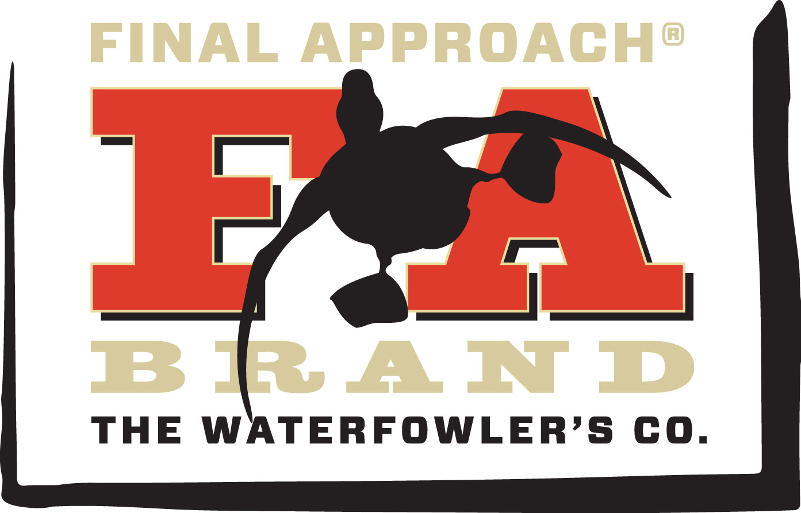
Contact: Jake Edson
Communications Manager
Outdoor Products
(763) 323-3865
E-mail: pressroom@vistaoutdoor.com

FOR IMMEDIATE RELEASE

Final Approach Announces New Products and Lifetime Warranty

FA Brand Announces New Blinds, Decoys, Rigging and Warranty at SHOT Show 2017

FLORA, Mississippi – January 13, 2017 – Final Approach, an industry innovator in blinds, decoys and accessories for hardcore waterfowl hunters, is set to unveil new blinds, decoys and rigging and an all-new Limited Lifetime Warranty at the 2017 Shooting Hunting and Outdoor Trade (SHOT) Show in Las Vegas, January 17-20 in booth #14551.

Established in 1993, FA Brand offers serious waterfowl hunters and guides a tough and innovative lineup of gear. And now, Final Approach is backing those products with a new “And That’s Final” Limited Lifetime Warranty on all blinds, rigging, bags and packs.

“Our guiding principle is that we rise earlier, think smarter, stay later and build better to make your gear tougher,” said Chelsea Pettitt, FA Brand Product Manager. “We are standing behind that with a warranty that flat-out promises our gear will work as hard as you do. And if it doesn’t, we’ll replace it.”

The new warranty also reflects enhanced materials and craftsmanship in new products, as well as improved relaunches of oft-requested favorites. Back by strong demand—
and with advanced materials for even better performance—FA Brand is re-launching the Original X-Land’r and Orginal Pro Guide layout blinds. With new coated fabrics to keep hunters dry in the worst conditions, the Original X-Land'r and Pro-Guide boast proven designs for maximum comfort and performance.
“Our customers told us they wanted the original dimensions and features of the Pro Guide and X-Land’r,” Pettitt said. “We listened, while also combining the latest in materials and craftsmanship, so we could stand behind these products with a lifetime warranty.”

Additional products unveiled at SHOT Show include new Field Canada Geese decoys with improved feather detail, new custom-sculpted positions and flocked heads and tails. Plus, new floating mallard decoys featuring new positions hand-carved by 14-time World Champion Carver, Pat Godin. The new one-piece design includes the head and keel for rock-solid durability. Finally, FA Brand announces heavy-duty rigging accessories. From Texas rigs to a do-it-yourself kit, Final Approach now offers premium plastisol coated weights and premium steel cable backed by our “And That’s Final” Warranty.

Final Approach is brand of Vista Outdoor. For more information, visit www.fabrand.com.

About Vista Outdoor
Vista Outdoor is a leading global designer, manufacturer and marketer of consumer products in the growing outdoor sports and recreation markets. The company operates in two segments, Shooting Sports and Outdoor Products, and has a portfolio of well-recognized brands that provides consumers with a wide range of performance-driven, high-quality and innovative products for individual outdoor recreational pursuits. Vista Outdoor products are sold at leading retailers and distributors across North America and worldwide. Vista Outdoor is headquartered in Utah and has manufacturing operations and facilities in 13 U.S. States, Canada, Mexico and Puerto Rico along with international customer service, sales and sourcing operations in Asia, Australia, Canada, Europe and New Zealand. For news and information, visit www.vistaoutdoor.com or follow us on Twitter @VistaOutdoorInc and Facebook at www.facebook.com/vistaoutdoor.
###

