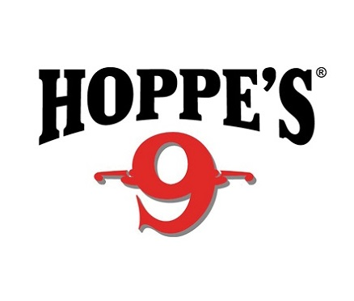

Contact: Jake Edson
Communications Manager
  - Outdoor Products
(763) 323-3865
FOR IMMEDIATE RELEASE E-mail: pressroom@vistaoutdoor.com

Hoppe’s Pro Jessie Duff Wins Ladies Open National Title at the 2017 US Steel Nationals

Jessie Duff Earns Her Eighth Ladies Open National Title

OVERLAND PARK, Kansas – April 11, 2017 – Hoppe’s Pro Jessie Duff recently took home her eighth Ladies Open National Title at the 2017 U.S. Steel Nationals in Covington, Georgia.

The U.S. Steel Nationals take place over three days, with the Open National title on the line. The event at the South River Gun Club featured top-ranked shooters from across the country, but Duff topped all other women. She also earned the High Lady Rimfire Optics title and clinched 3rd in the Single Stack competition.

Throughout the course, Duff relied on her Hoppe’s cleaning products to keep her firearms in top condition. Hoppe’s has earned the reputation as “The Gun Care People” for more than 100 years. Hoppe’s newest line, Hoppe’s Black, uses a formula designed for MSR’s and other high-round count firearms, but will work with any firearm. Designed to withstand a wide range of temps from -65°F to 540°F, it will prepare any gun for any situation. Hoppe’s Black is comprised of a Gun Cleaner, Precision Oil, Copper Cleaner, Grease Syringe, and Lubricating Cloth. For more information on their innovative new line of cleaners visit www.hoppes.com/black.

About Vista Outdoor
Vista Outdoor is a leading global designer, manufacturer and marketer of consumer products in the growing outdoor sports and recreation markets. The company operates in two segments, Shooting Sports and Outdoor Products, and has a portfolio of well-recognized brands that provides consumers with a wide range of performance-driven, high-quality and innovative products for individual outdoor recreational pursuits. Vista Outdoor products are sold at leading retailers and distributors across North America and worldwide. Vista Outdoor is headquartered in Utah and has manufacturing operations and facilities in 13 U.S. States, Canada, Mexico and Puerto Rico along with international customer service, sales and sourcing operations in Asia, Australia, Canada, Europe and New Zealand. For news and information, visit www.vistaoutdoor.com or follow us on Twitter @VistaOutdoorInc and Facebook at www.facebook.com/vistaoutdoor.
###

