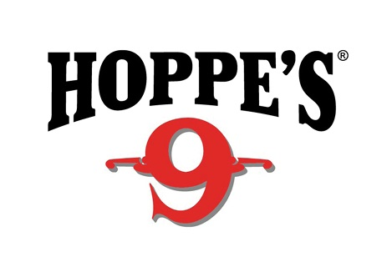
Contact: Jake Edson
Communications Manager
Outdoor Products
(763) 323-3865
FOR IMMEDIATE RELEASE E-mail: pressroom@vistaoutdoor.com

Hoppe’s Presents Shooting Sports Celebrities at 2017 NRA Annual Meetings and Exhibits Show

OVERLAND PARK, Kansas (April 25, 2017) – Hoppe’s, the best-known name in gun care products, welcomes competitive shooting icons to the Vista Outdoor booth (#2542) at the 2017 NRA Meetings and Exhibits Show in Atlanta, Georgia, April 27 to 30. Show attendees will have the opportunity to meet “Shooting USA” host John Scoutten and world-champion shooter Jessie Duff, as well as long-range standout Missy Gilliland and practical shooting expert Maggie Reese.

Scoutten is the producer and Emmy award nominee co-host of the Outdoor Channel’s “Shooting USA.” He also competes in multiple shooting events, including NRA Action Pistol, Steel Challenge and PRS, among others. On Friday, April 28, Scoutten will host a product demonstration at 1 p.m. followed by a question-and-answer session at 1:30.

Widely regarded as one of the world’s most accomplished competitive shooters, Duff has won both world and national championship titles, including the Bianchi Cup and the Steel Challenge World Speed Shooting Championships. She recently took home her eighth Ladies Open National Title at the 2017 U.S. Steel Nationals. Duff will conduct gun-care product demonstrations from 1:30-2 p.m. on Saturday, April 29.

Gilliland is a top contender on the Precision Rifle Series (PRS), co-hosted seasons 2-8 of Trigger Time TV on the Pursuit Channel, and is a tireless promoter of women in the shooting sports. Gilliland will host a product demonstration and question-and-answer session from 10:30-11 a.m. on Friday, April 28. She will also conduct a product demonstration from 10:30-11 a.m. on Sunday, April 30.

Reese is well-known for appearances on the History Channel’s “Top Shot!” Season 2 cast, Sportsman Channel’s “3-Gun Nation” and “Modern Shooter,” and Outdoor Channel’s “Shooting USA.” She is a three-time U.S. Practical Shooting Association multi-gun national champion and has won multiple Ladies 3-Gun champions titles at Superstition Mountain Mystery, MGM Ironman and Rocky Mountain 3-Gun. Reese will present a gun-care product demonstration from 3-3:30 p.m. on Friday, April 28.

Duff, Gilliland and Reese will also participate in a special “Women of Vista” question-and-answer session from 4-5 p.m. on Saturday, April 29.

All attendees are encouraged to stop by the Vista Outdoor booth (#2542) to visit with their favorite celebrities and learn more about the latest products offered by Hoppe’s.

Hoppe’s, a Vista Outdoor, Inc. brand, serves shooters of all disciplines, offering gun care products that meet the rigorous standards Hoppe’s established more than 110 years ago. Learn more at www.hoppes.com.

About Vista Outdoor
Vista Outdoor is a leading global designer, manufacturer and marketer of consumer products in the growing outdoor sports and recreation markets. The company operates in two segments, Shooting Sports and Outdoor Products, and has a portfolio of well-recognized brands that provides consumers with a wide range of performance-driven, high-quality and innovative products for individual outdoor recreational pursuits. Vista Outdoor products are sold at leading retailers and distributors across North America and worldwide. Vista Outdoor is headquartered in Utah and has manufacturing operations and facilities in 13 U.S. States, Canada, Mexico and Puerto Rico along with international customer service, sales and sourcing operations in Asia, Australia, Canada, Europe and New Zealand. For news and information, visit www.vistaoutdoor.com or follow us on Twitter @VistaOutdoorInc and Facebook at www.facebook.com/vistaoutdoor.
###

