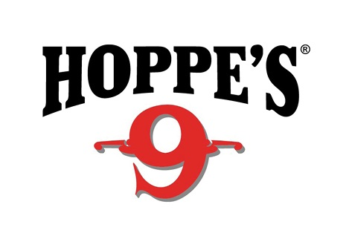
Contact: Jake Edson
Communications Manager
Outdoor Products
(763) 323-3865
FOR IMMEDIATE RELEASE E-mail: pressroom@vistaoutdoor.com

Hoppe’s, ‘the Gun Care People,’ Present Shooting Sports Celebrities at 2017 SHOT Show

OVERLAND PARK, Kansas – January 13, 2017 – Hoppe’s, the best-known name in gun care products, welcomes competitive shooting icons to the Vista Outdoor booth (#14551) at the 2017 Shooting Hunting and Outdoor Trade (SHOT) Show in Las Vegas, January 17-20. Show attendees will have the opportunity to meet “Shooting USA” host John Scoutten and world-champion shooter Jessie Duff, as well as long-range standout Missy Gilliland and practical shooting expert Maggie Reese.

Widely regarded as one of the world’s most accomplished competitive shooters, Duff has won both world and national championship titles, including the Bianchi Cup and the Steel Challenge World Speed Shooting Championships.

Duff will join gun guru John Scoutten for product demonstrations on Tuesday, January 17, from 4-5 p.m. Scoutten is the producer and Emmy award nominee co-host of the Outdoor Channel’s “Shooting USA” and also competes in multiple shooting events, including NRA Action Pistol, Steel Challenge and PRS, among others.

Gilliland is a top contender on the Precision Rifle Series (PRS), co-hosted seasons 2-8 of Trigger Time TV on the Pursuit Channel, and is a tireless promoter of women in the shooting sports. Reese is well-known for appearances on the History Channel’s “Top Shot!” season two cast, Sportsman Channel’s “3-Gun Nation” and “Modern Shooter,” and Outdoor Channel’s “Shooting USA.” She is a three-time U.S. Practical Shooting Association multi-gun national champion and has won multiple Ladies 3-Gun champions titles at Superstition Mountain Mystery, MGM Ironman and Rocky Mountain 3-Gun.

Gilliland and Reese will participate in a special Q&A session from noon to 1 p.m. on Thursday, January 19.

All attendees are encouraged to stop by the Vista Outdoor booth (#14551) at the 2017 SHOT Show to visit with their favorite celebrities and learn more about the latest products offered by Hoppe’s.

Hoppe’s, a Vista Outdoor brand, serves shooters of all disciplines, offering gun care products that meet the rigorous standards Hoppe’s established more than 110 years ago. www.hoppes.com.

About Vista Outdoor
Vista Outdoor is a leading global designer, manufacturer and marketer of consumer products in the growing outdoor sports and recreation markets. The company operates in two segments, Shooting Sports and Outdoor Products, and has a portfolio of well-recognized brands that provides consumers with a wide range of performance-driven, high-quality and innovative products for individual outdoor recreational pursuits. Vista Outdoor products are sold at leading retailers and distributors across North America and worldwide. Vista Outdoor is headquartered in Utah and has manufacturing operations and facilities in 13 U.S. States, Canada, Mexico and Puerto Rico along with international customer service, sales and sourcing operations in Asia, Australia, Canada, Europe and New Zealand. For news and information, visit www.vistaoutdoor.com or follow us on Twitter @VistaOutdoorInc and Facebook at www.facebook.com/vistaoutdoor.
###

