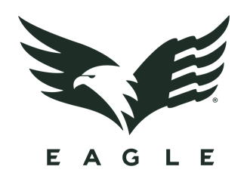
Contact: Willie Vernon
Senior Director of Marketing
E-mail: willie.vernon@vistaoutdoor.com

FOR IMMEDIATE RELEASE

Eagle : BEYOND Episode 2 // NO QUIT – Now Live

VIRGINIA BEACH, Virginia – October 24, 2019 – Eagle Industries, a leader in the outdoor and military gear space for over 30 years, announced today that is continuing its commitment to excellence with the second edition of its cinematic series Eagle : BEYOND, a series that focuses on four top-tier military personnel who are now taking their experience and training to the next level in their lives post-service. Episode 2, aptly named NO QUIT, centers around Jeff Reid, Navy SEAL turned professional dog musher.

Jeff and his wife, Jeri, reside in Two Rivers, Alaska outside of Fairbanks. This seemingly drastic career change is more natural than one might initially think – Jeff manages to work his team tactics and leadership training from his time as a SEAL into how he interacts with his sled dog team in inventive and inspirational ways.

Episode 2 : NO QUIT gives viewers a glimpse of the trials, tribulations, and intense mindset that go into finding success as a dog musher in the harsh landscape of the Alaskan winter. When you find yourself breaking through the ice of a frozen river with your sled pinned under a sheet of ice as your dogs struggle to keep from going under, the only things that will save you are your mindset, your team, and your gear. Watch NO QUIT to see how Jeff and his four-legged team utilize their training to overcome this and many other obstacles on their journey to excellence.

To view Eagle : BEYOND Episode 1 and Episode 2, visit https://eagleindustries.com/videos/

About Eagle Industries
Eagle Industries was born from the uncompromising demands of the Navy SEAL community, and those standards are still what drive everything we do to this day. All of our gear is Berry Compliant and proudly made in the USA to ensure our end users – from top-tier military to backcountry adventurers – have exactly what they need to go above and beyond every day.

