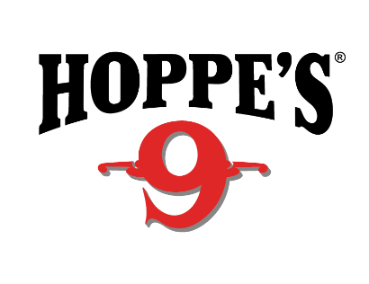
Contact: Jake Edson
Communications Manager
Outdoor Products
(763) 323-3865
FOR IMMEDIATE RELEASE E-mail: pressroom@vistaoutdoor.com

Hoppe’s Elite Helps Jessie Harrison Continue USPSA Dominance

Jessie Harrison Continues to Win with Hoppe’s Gun Cleaning Products

OVERLAND PARK, Kansas – July 1, 2019 – Hoppe’s, the best-known name in gun care products, continues to find shared success with Hoppe’s team shooter Jessie Harrison as she continues her dominance in the competitive shooting sports. At the recent U.S. Practical Shooting Association (USPSA) Area 7 Championships, Harrison took first place in the Ladies Open Division and placed fifth in the overall competition.

Harrison is the first female shooter to achieve Grand Master status with the USPSA and boasts an impressive list of accolades across five shooting disciplines, including multiple World and National Champion shooting titles. Among these are the prestigious Bianchi Cup and the World Speed Shooting Championships.

Throughout the competition, Harrison relied on Hoppe’s Elite gun cleaner and gun oil and the Hoppe’s BoreSnake Viper that is almost as fast as she is.

“In addition to every day maintenance, cleaning my gun is part of my pre-match routine,” Harrison said. “Hoppe’s has products for every level of cleaning, be it a quick wipe down between practices or a deep clean before a competition. There’s no better feeling than the first shots out of a clean gun!”

Hoppe’s No. 9 remains the most widely used remover of powder, lead and metal-fouling rust on the market. But Hoppe’s provides much more than that, including Hoppe’s Black, Gun Medic, Elite, BoreSnakes, cleaning kits, tools and accessories. The Hoppe’s Elite cleaning line was designed with the top-end hunter and shooter in mind. A complete departure from traditional Hoppe’s No. 9 solvent, this high-tech, odorless technology outperforms standard cleaners and oils under any condition. Likewise, the BoreSnake Viper makes cleaning fast and easy, with even better cleaning and superior strength than the original BoreSnake.

For more information on Harrison, check out her Facebook fan page at www.facebook.com/jessielharrison/.

To learn more about Hoppe’s, visit the website at www.hoppes.com.

About Hoppe’s
In 1903, Frank August Hoppe mixed nine chemicals and created the world’s most effective gun cleaner. As a well-trained young soldier, Frank knew that gun care went far beyond just a clean rifle, but actually helped to ensure his safety while on the front lines of battle. Since that time, Hoppe’s has emerged as the leading gun care company, having grown along-side hunters, shooters, and soldiers who depend on their firearms every day. It has remained the most trusted name in gun care by advancing and evolving technologies to meet those needs. From the ever-popular and versatile No. 9 and the quick and easy BoreSnake, to the marvel of efficiency we call Gun Medic, Hoppe’s is the only name you need to know for firearm cleaning and protection. For more information, visit www.hoppes.com, connect on Instagram at www.instagram.com/hoppesguncare/ or on Facebook at www.facebook.com/hoppesguncare.

