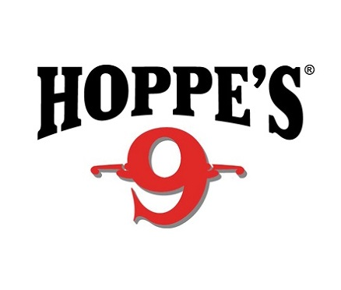

Contact: Jake Edson
Communications Manager
Outdoor Products
(763) 323-3865
FOR IMMEDIATE RELEASE E-mail: pressroom@vistaoutdoor.com

Limited Edition “I Sweat Hoppe’s” Shirts Available from Nine Line Apparel

“I Sweat Hoppe’s” Shirts Available Online Only January 18 to February 4

OVERLAND PARK, Kansas – January 18, 2019 – Hoppe’s, the best known name in gun care products, is proud to announce a limited run of Nine Line Apparel “I Sweat Hoppe’s” T-shirts and sweatshirts. The new shirts are available exclusively online and for a limited time.

Nine Line Apparel is a Savannah, Georgia based, veteran owned and operated clothing brand. With a tagline of "Relentlessly Patriotic", Nine Line is a “give-back organization” that outfits veterans, active military, first responders and their supporters. At its core, Nine Line says it aims to reinvigorate the sense of patriotism and national pride that is disappearing daily from our society.

Hoppe’s, makers of the legendary gun cleaning solution Hoppe’s No. 9, serves shooters of all disciplines, and offers gun care products that meet the rigorous standards Frank Hoppe established more than 110 years ago.

“Hoppe’s is an iconic brand within the firearms world,” said Eliza Graves, Hoppe’s Brand Manager. “Everyone has a Hoppe’s No. 9 memory. We all can think back and associate the smell of Hoppe’s No. 9 to a particular time or place. Our customers value that, and they fly the Hoppe’s flag with pride. Now, they can wear it!”

Available in several styles, “I Sweat Hoppe’s” shirts are only available while supplies last. Visit the website at www.ninelineapparel.com/collections/hoppes-9 to order one today.

About Hoppe’s
In 1903, Frank August Hoppe mixed nine chemicals and created the world’s most effective gun cleaner. As a well-trained young soldier, Frank knew that gun care went far beyond just a clean rifle, but actually helped to ensure his safety while on the front lines of battle. Since that time, Hoppe’s has emerged as the leading gun care company, having grown along-side hunters, shooters, and soldiers who depend on their firearms every day. It has remained the most trusted name in gun care by advancing and evolving technologies to meet those needs. From the ever-popular and versatile No. 9 and the quick and easy BoreSnake, to the marvel of efficiency we call Gun Medic, Hoppe’s is the only name you need to know for firearm cleaning and protection. For more information, visit www.hoppes.com, connect on Instagram at https://www.instagram.com/hoppesguncare/ or on Facebook at https://www.facebook.com/hoppesguncare.

###

