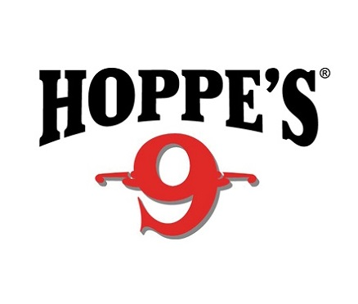

Contact: Jake Edson
Communications Manager
Outdoor Products
(763) 323-3865
FOR IMMEDIATE RELEASE E-mail: pressroom@vistaoutdoor.com

Hoppe’s Welcomes Shooting Sports Stars to Booth #14551

Meet Top Shooters Lena Miculek, Jessie Harrison, Maggie Reese and John Scoutten in the Hoppe’s Booth

OVERLAND PARK, Kansas – January 18, 2019 – Hoppe’s, the best known name in gun care products, will host top competitive shooters in the booth (#14551) at the 2019 Shooting Hunting and Outdoor Trade (SHOT) Show in Las Vegas, Nevada, January 22-25. Show attendees will have the opportunity to meet world-class shooters Lena Miculek, Jessie Harrison, Maggie Reese and John Scoutten.

Lena Miculek, the newest addition to the Hoppe’s Ambassador team, will be in the booth for a meet and greet Tuesday, January 22 and Thursday, January 24 from 4 to 5 p.m. Miculek is a professional shooter who started competing at just 8 years old. Working as a full time professional competitive shooter for 6 years now, her past accomplishments include placing in the lady division at the NRA World Shooting Competition, IPSC Rifle World Shoot in Russia and High Lady at the USPSA Optic Nationals with PCC.

Recognized as one of the most accomplished competition shooters in the world, Jessie Harrison has won both world and national championship titles, including the Bianchi Cup and the Steel Challenge World Speed Shooting Championships. Harrison will be in the Hoppe’s booth January 23, from 11:30 a.m. to 12:30 p.m. and January 25 from 11:30 a.m. to 12:30 p.m.

Maggie Reese, a professional shooter and USPSA champion, will be in the booth Tuesday, January 22 and Thursday, January 24 from 11 a.m. to noon. Reese is a three-time National Champion in USPSA Multi-Gun, and multiple Ladies Champion at Superstition Mountain Mystery 3-Gun, MGM Ironman 3-Gun and Rocky Mountain 3-Gun. She was also a “Top Shot” cast member.

“Shooting USA” host and gun guru John Scoutten will be available to meet with show attendees on Tuesday, January 22 and Thursday, January 24 from 1:30 to 3:00 p.m. Scoutten interviews and participates alongside the best competitive shooters in the nation.

All attendees are encouraged to stop by booth #14551 to visit with their favorite shooting sports celebrities and learn more about the latest products offered by Hoppe’s, including the revolutionary new Hoppe’s AirVault, which protects firearms by creating a molecular barrier against the corrosive effects of moisture, salt, and other contaminants. To store a firearm, simply clean the firearm per the manufacturer’s recommendation, place the unloaded firearm in the AirVault bag and securely press zipper closed.
AirVault protects a clean firearm from rust for up to five years.

Hoppe’s, a Vista Outdoor brand, serves shooters of all disciplines, and offers gun care products that meet the rigorous standards Frank Hoppe established more than 110 years ago. Visit the website at www.hoppes.com.

About Hoppe’s
In 1903, Frank August Hoppe mixed nine chemicals and created the world’s most effective gun cleaner. As a well-trained young soldier, Frank knew that gun care went far beyond just a clean rifle, but actually helped to ensure his safety while on the front lines of battle. Since that time, Hoppe’s has emerged as the leading gun care company, having grown along-side hunters, shooters, and soldiers who depend on their firearms every day. It has remained the most trusted name in gun care by advancing and evolving technologies to meet those needs. From the ever-popular and versatile No. 9 and the quick and easy BoreSnake, to the marvel of efficiency we call Gun Medic, Hoppe’s is the only name you need to know for firearm cleaning and protection. For more information, visit www.hoppes.com, connect on Instagram at https://www.instagram.com/hoppesguncare/ or on Facebook at https://www.facebook.com/hoppesguncare.

###

