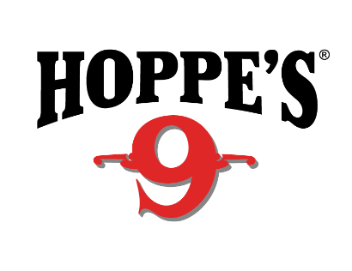
Contact: Jake Edson
Communications Manager
Outdoor Products
(763) 323-3865
FOR IMMEDIATE RELEASE E-mail: pressroom@vistaoutdoor.com

Hoppe’s Pro Jessie Harrison Wins US Steel Nationals

Jessie Harrison Wins Ninth Ladies Open Title at 2019 U.S. Steel National Championship

OVERLAND PARK, Kansas – April 11, 2019 – Hoppe’s, the No. 1 name in gun care, congratulates Jessie Harrison on her continued dominance at the 2019 U.S. Steel National Championship in Covington, Georgia. In a field of 460 of the Nation’s top shooters, Harrison won the Overall Single Stack division and the Ladies Open division, delivering her ninth Ladies Open National Title.

Harrison is the first female shooter to achieve Grand Master status with the U.S. Practical Shooting Association (USPSA) and boasts an impressive list of accolades across five shooting disciplines, including multiple World and National Champion shooting titles. Among these are the prestigious Bianchi Cup and the World Speed Shooting Championships.

“Capturing the Ladies Open title this year is exciting,” Harrison said. “It’s important to trust in your equipment, and I use Hoppe’s before, during and after a match to make sure my guns are in racing condition. I really look forward to the rest of the season with Hoppe’s by my side!”

Harrison began shooting competitively in Cowboy Action Shooting tournaments at the age of 15. She soon added multiple disciplines, including USPSA and Steel Challenge, then Multi-Gun and the NRA Bianchi Cup. Today, she is one of the most awarded shooters of all time, with dozens of World and National Championship titles to her credit. In addition to this ninth Ladies Open National Title, Harrison owns an unprecedented 20 USPSA Ladies National Titles.

For more information on Harrison, check out her Facebook fan page at www.facebook.com/jessielharrison/.

Hoppe’s, a Vista Outdoor brand, serves shooters of all disciplines, and offers gun care products that meet the rigorous standards Frank Hoppe established more than 115 years ago. Visit the website at www.hoppes.com.

About Hoppe’s
In 1903, Frank August Hoppe mixed nine chemicals and created the world’s most effective gun cleaner. As a well-trained young soldier, Frank knew that gun care went far beyond just a clean rifle, but actually helped to ensure his safety while on the front lines of battle. Since that time, Hoppe’s has emerged as the leading gun care company, having grown along-side hunters, shooters, and soldiers who depend on their firearms every day. It has remained the most trusted name in gun care by advancing and evolving technologies to meet those needs. From the ever-popular and versatile No. 9 and the quick and easy BoreSnake, to the marvel of efficiency we call Gun Medic, Hoppe’s is the only name you need to know for firearm cleaning and protection. For more information, visit www.hoppes.com, connect on Instagram at www.instagram.com/hoppesguncare/ or on Facebook at www.facebook.com/hoppesguncare.

###

