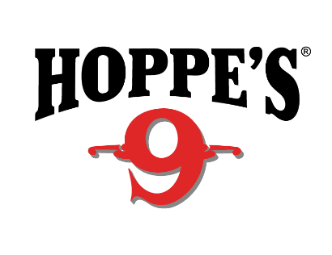
Contact: Jake Edson
Communications Manager
Outdoor Products
(763) 323-3865
FOR IMMEDIATE RELEASE E-mail: pressroom@vistaoutdoor.com

Champion Shooter Todd Jarrett Joins Hoppe’s Team

OVERLAND PARK, Kansas – April 10, 2019 – Hoppe’s, the best-known name in gun care products, announces the signing of National and World Practical Shooting champion Todd Jarrett to the Hoppe’s Ambassador Program. He will represent Hoppe’s at shooting competitions, appearances at shows and assess products.

Jarrett has been a dominant force in practical shooting for the past 25 years. He currently holds four World titles and 13 National Championships, and has won more than 100 area and regional championships and countless other action shooting events. He is the only USPSA Triple Crown winner and holds USPSA National titles in four divisions: Open, Limited, Production and Limited-10.

In addition, Jarrett is a popular firearms instructor for military, law-enforcement and competitive shooters throughout the world. His expertise in firearm manipulation and shooting techniques has enhanced the skills of countless people and agencies. His involvement in the firearms industry has led to the development of many new products that have proven invaluable to competitive shooters, military and law enforcement.

“Todd is an incredible instructor and shooter,” said Hoppe’s Brand Manager Eliza Graves. “We’re proud and excited to have him join our Ambassador Program. He truly understands the importance of firearm maintenance, and he will be an invaluable part of the Hoppe’s team.”

Hoppe’s, a Vista Outdoor brand, serves shooters of all disciplines, and offers gun care products that meet the rigorous standards Frank Hoppe established more than 115 years ago. Visit the website at www.hoppes.com.

About Hoppe’s
In 1903, Frank August Hoppe mixed nine chemicals and created the world’s most effective gun cleaner. As a well-trained young soldier, Frank knew that gun care went far beyond just a clean rifle, but actually helped to ensure his safety while on the front lines of battle. Since that time, Hoppe’s has emerged as the leading gun care company, having grown along-side hunters, shooters, and soldiers who depend on their firearms every day. It has remained the most trusted name in gun care by advancing and evolving technologies to meet those needs. From the ever-popular and versatile No. 9 and the quick and easy BoreSnake, to the marvel of efficiency we call Gun Medic, Hoppe’s is the only name you need to know for firearm cleaning and protection. For more information, visit www.hoppes.com, connect on Instagram at www.instagram.com/hoppesguncare/ or on Facebook at www.facebook.com/hoppesguncare.

###

