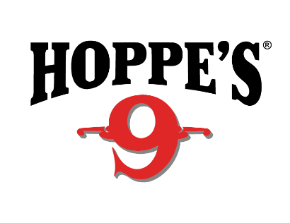
Contact: Jake Edson
Communications Manager
Outdoor Products
(763) 323-3865
FOR IMMEDIATE RELEASE E-mail: pressroom@vistaoutdoor.com

Hoppe’s Pro Shooters Take the Stage at 2019 NRA Show in Indianapolis

Meet Hoppe’s Shooting Ambassadors, Win Prizes and See New Products in Booth #4955

OVERLAND PARK, Kansas – April, 24, 2019 – Hoppe’s, the best known name in gun care products, will host top competitive shooters in Booth #4955 at the 2019 NRA Meetings & Exhibits Show April 26 to 28 in Indianapolis. Show attendees can meet and get tips from Todd Jarrett, Jessie Harrison, Lena Miculek, Maggie Reese-Voigt and John Scoutten. Hoppe’s will also be showing several new products and drawing names for giveaways each day of the show.

Jarrett, the newest addition to the Hoppe’s Ambassador Team, has been a dominant force in practical shooting for the past 25 years. He currently holds four World titles and 13 National Championships. He has won more than 100 area and regional championships and countless other action shooting events. He is the only USPSA Triple Crown winner and holds USPSA National titles in four divisions: Open, Limited, Production and Limited-10. He will be on the main stage in Booth #4955 from 11 a.m. to noon on April 26 as well as 10 to 11 a.m. and 5 to 6 p.m. April 27. He will also be in the Hoppe’s new product area from 11 a.m. to noon on April 28.

Miculek is a professional shooter from Arkansas, who started shooting competitively at just 8 years old. Her accomplishments include placing in the lady division at the NRA World Shooting Competition, IPSC Rifle World Shoot in Russia and High Lady at the USPSA Optic Nationals with PCC. She will be on the main stage from 2 to 3 p.m. on April 26 and in the Hoppe’s new product area on April 27 from 2 to 3 p.m. On April 28, she will join Reese-Voigt on the main stage from 1 to 2 p.m.

Reese-Voigt is well-known for appearances on multiple shooting competition shows, is a USPSA MultiGun National Champion and has won multiple Ladies 3-Gun champion titles. She will join Harrison and Miculek on the main stage on April 26 from 2 to 3 p.m., and will co-host a discussion with Miculek from 1 to 2 p.m. on April 28. On Saturday, April 27, she will answer questions in the Hoppe’s new product area from 4 to 5 p.m.

Recognized as one of the most accomplished competition shooters in the world, Harrison has won both world and national championship titles, including the Bianchi Cup and the Steel Challenge World Speed Shooting Championships. She will be in the Hoppe’s product lane April 26 and 27 from 1:30 to 2 p.m. and on the main stage on April 26 from 2 to 3 p.m.

“Shooting USA” host and gun guru John Scoutten will be available to meet with show attendees in the Hoppe’s area on April 26 from 3 to 4 p.m. He will also host a discussion with Jarrett on April 27 from 10 to 11 a.m.

In addition to the celebrity appearances and discussions, Hoppe’s will also be demonstrating new products and drawing names for booth giveaways each day of the show.

Hoppe’s, a Vista Outdoor brand, serves shooters of all disciplines, and offers gun care products that meet the rigorous standards Frank Hoppe established more than 115 years ago. Visit the website at www.hoppes.com.

About Hoppe’s
In 1903, Frank August Hoppe mixed nine chemicals and created the world’s most effective gun cleaner. As a well-trained young soldier, Frank knew gun care went beyond a clean rifle, but actually helped ensure safety while on the front lines of battle. Since then, Hoppe’s has emerged as the leading gun care company, growing along-side hunters, shooters, and soldiers who depend on their firearms every day. It has remained the most trusted name in gun care by advancing and evolving technologies to meet those needs. From the ever-popular and versatile No. 9 and the quick and easy BoreSnake, to the marvel of efficiency we call Gun Medic, Hoppe’s is the only name you need to know for firearm cleaning and protection. For more information, visit www.hoppes.com, connect on Instagram at www.instagram.com/hoppesguncare/ or on Facebook at www.facebook.com/hoppesguncare.

