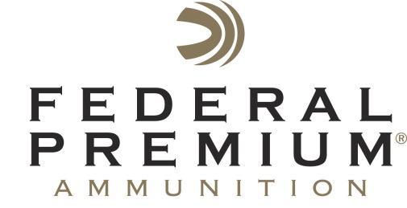
Contact: JJ Reich
Public Relations Specialist
763-323-3862
FOR IMMEDIATE RELEASE E-mail: pressroom@atk.com

Federal Premium® Sponsors 2013 Big Game Awards

Federal Premium® Ammunition will sponsor the Boone & Crocket Club’s 28th Big Game Awards, July 17-20, 2013 in Reno, Nev. The triennial event showcases big game animals and their conservation. This year’s awards will include an exhibition of world records, the Boone & Crockett Club’s Top 5 trophies, and record-book specimens taken by hunters age 16 and under. It will also offer raffles, an auction for dream hunts and evening awards banquets.

ANOKA, Minn. – July 15, 2013 – Federal Premium® Ammunition has announced its sponsorship of the Boone & Crocket Club’s 28th Big Game Awards, July 17-20, 2013 in Reno, Nev.

“Federal Premium Ammunition is proud to partner with the oldest hunter-conservationist organization,” said Ryan Bronson, Federal’s Senior Manager of Conservation and Public Policy. “The Boone & Crocket Club is a pillar organization when it comes to promoting hunting ethics and respect for wildlife. The priorities of both organizations match up to form a great partnership that will make a difference for big game and other wildlife populations.”

Organizers started the triennial event in 1947 to showcase superb big game animals and their conservation. This year’s awards will include an exhibition of world records, the Boone & Crockett Club’s Top 5 trophies, and record-book specimens taken by hunters age 16 and under during the past three years. The event also offers raffles, an auction for dream hunts and evening awards banquets.

“By sponsoring our 28th Big Game Awards, Federal Premium is helping us spread the word that America’s conservation system continues to work well today,” said Boone & Crockett Club President Bill Demmer. “In fact, most big game herds are healthier and world-class trophies are more plentiful now than ever before, thanks to hunters.”

For more information on the 2013 Big Game Awards, visit www.biggameawards.com; to learn more about Federal Premium, go to www.federalpremium.com.

