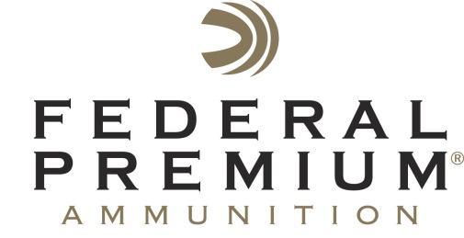
Contact: Tim Brandt
Federal Premium
800-322-2342 (ext. 3833)
FOR IMMEDIATE RELEASE E-mail: pressroom@atk.com

Federal Premium® Ammunition and CCI® Allocate 20 Million Rounds of .22 LR Ammunition for Youth Shooting Sports Programs

The current market and environment has caused a higher than usual demand for ammunition across the industry. One area hit particularly hard is rimfire ammunition. Many youth organizations, events and camps rely on the popular and affordable .22 LR for training, practice and recreational shooting. In order to ensure that essential educational shooting programs can go on according to plan, Federal Premium Ammunition® and CCI® have set aside 20 million rounds of .22 LR for approved youth shooting sports programs. This limited program will support well-known organizations such as the 4-H Shooting Sports, Boy Scouts of America and others associated with the Youth Shooting Sports Alliance.

ANOKA, Minn. – May 2, 2013 – Federal Premium® Ammunition and sister company CCI® have dedicated 20 million rounds of rimfire ammunition to youth shooting sports programs. The Boy Scouts of America will receive 10 million .22 LR shells, and another 10 million will be sent to other organizations. This product sold at a discounted price will ship directly to the Boys Scouts of America, 4-H Shooting Sports and other qualified youth organizations. The ammunition distribution process was in cooperation with the Youth Shooting Sports Alliance (YSSA). Delivery is expected in May and will help ensure that many camps, shooting programs and trainings can occur over the summer.

The consumer demand for ammunition over the last several months has put a strain on manufacturers across the country. Both Federal Premium and CCI continue to run their plants 24 hours a day, seven days a week—as they have for years. Despite the best efforts of over 2,000 employees working around the clock, customers are having trouble finding ammunition.

“We work very closely with several youth organizations who promote the youth shooting sports,” said Federal Premium Conservation Manager Ryan Bronson.

-more-

“Their efforts are very important to us, and always have been. Many of them rely on rimfire ammunition to educate and teach tomorrow’s hunters and shooting sports enthusiasts. The current demand has put a strain on their ability to continue to operate. We hope this special allocation will ease some of the pressure, and keep our young people doing what they love—shooting and hunting.”

Federal Premium and CCI took applications and requests until April 30. Through a regimented process all 20 million rounds have been allocated. The recipients of this ammunition include notable organizations like the 4-H Shooting Sports, Boy Scouts of America, Scholastic Steel Challenge and other friends of the Youth Shootings Sports Alliance. All participants in this program have been vetted and are well-documented supporters of the youth shooting sports.

Federal Premium and CCI have been dedicated to conservation and youth outreach programs for decades. The latest allocation of 20 Million .22 LR rounds supports the need for affordable and reliable ammunition.

To learn more, visit www.federalpremium.com and www.cci-ammuntion.com.

###

