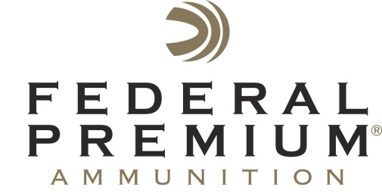
Contact: JJ Reich
Public Relations Specialist
763-323-3862
FOR IMMEDIATE RELEASE E-mail: pressroom@atk.com

Federal Premium Signs On as Pheasants Forever’s 2015 National Pheasant Fest & Quail Classic Presenting Sponsor

Federal Premium® Ammunition is now the presenting sponsor of the National Pheasant Fest & Quail Classic, which will take place February 20-22, 2015 in Des Moines, Iowa. The event sponsorship reinforces the support of Federal Premium Ammunition of Pheasants Forever, the nation’s leading upland habitat conservation organization. A maker of products that make days in the field more enjoyable and successful, Federal Premium Ammunition also recently product-sponsored a short film that celebrates pheasant hunting, “The Weekend Shift.”

ANOKA, Minn. – November 20, 2014 – Federal Premium® Ammunition continues its support of Pheasants Forever’s upland hunting and wildlife habitat conservation mission by becoming the presenting sponsor of the upcoming 2015 National Pheasant Fest & Quail Classic. The event will take place February 20-22, 2015 at the Iowa Events Center in Des Moines, Iowa.

“We are extremely proud to have a larger part in the nation’s largest and most exciting upland hunting and conservation event,” said Federal Premium Marketing Director Jason Nash. “Pheasants Forever is a great example of an organization adding acres of habitat and access for hunters to enjoy now and into the future.”

The annual event for both Pheasants Forever and Quail Forever will feature a convention, trade show and other special events including:
- Bird Dog Bonanza Stage- Training seminars from top dog trainers in the country
- Wild Game Cooking Stage- New and exciting recipes for wild game
- Landowner Habitat Help Room- Free conservation consulting for landowners
- Youth Village- Free entertainment and outdoor instruction for kids of all ages

For more information on the National Pheasant Fest & Quail Classic, go to www.pheasantfest.org.

“Federal Premium is a true partner in conservation. They clearly understand the connection to our habitat conservation mission and their business’s success,” explained Joe Duggan, Pheasants Forever’s Vice President of Corporate Relations. “For more than three decades, Federal Premium has been investing in habitat and our hunting heritage’s future through Pheasants Forever and Quail Forever. This year’s decision to become the presenting sponsor of Pheasant Fest illustrates Federal Premium’s commitment to bird hunters across the country yet again.”

As a part of its ongoing support for upland hunting and habitat conservation, Federal Premium Ammunition is proud to be associated with the new short film, “The Weekend Shift,” in which a group of friends capture their fun-filled pheasant-hunting trip to North Dakota.

To see “The Weekend Shift” on the Federal Premium YouTube channel, go to youtu.be/X2Ny-VEMxWc.

“The Weekend Shift is a great reminder of why we love the fall and pheasant hunting,” said Nash. “Whether you share the field with old friends or new, it’s where memories are made. The Federal Premium brand is about getting into the field at every opportunity and celebrating friends, habitat and the outdoors. We’re excited to share content that gets to the heart of why we hunt.”

For more on Federal Premium, go to www.federalpremium.com.

