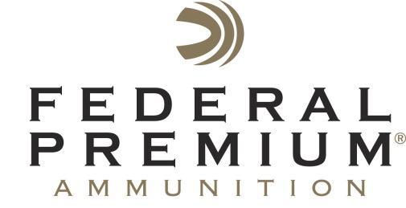
Contact: JJ Reich
Public Relations Specialist
763-323-3862
FOR IMMEDIATE RELEASE E-mail: pressroom@atk.com

Federal Premium to Host Meet-and-Greet with Chad Belding Star of “The Fowl Life” at 2014 NRA Show

Federal Premium® welcomes TV host Chad Belding from “The Fowl Life” to booth #6152 from 2 p.m. to 3 p.m., April 25 and 26 at the 143rd NRA Annual Meetings & Exhibits in Indianapolis, Ind. Belding is a passionate and experienced waterfowler who relies on Black Cloud®. He will sign autographs and swap stories with fellow hunters.

ANOKA, Minn. – April 9, 2014 – Federal Premium® Ammunition is pleased to invite attendees of the 143rd NRA Annual Meetings & Exhibits to a special meet-and-greet with Chad Belding, host of the popular TV show “The Fowl Life.” Belding will be in booth #6152 from 2 p.m. to 3 p.m., April 25 and 26 to meet fans, sign autographs and swap stories.

Belding is a passionate waterfowl hunter with extensive experience. While visiting the booth, he’ll discuss the role of specialized Federal Premium loads such as Black Cloud® Close Range in his hunting.

Close Range uses a specially designed FLITECONTROL® wad and a payload that’s comprised entirely of FLITESTOPPER® Steel pellets to achieve a full pattern within 20 to 30 yards. It offers the most lethal pattern possible for hunting timber or decoying waterfowl.

The NRA Annual Meetings & Exhibits will be held at the Indiana Convention Center in Indianapolis, Ind., April 25 through April 27, 2014.

To view the lineup of Federal Premium Ammunition, please visit www.federalpremium.com.

