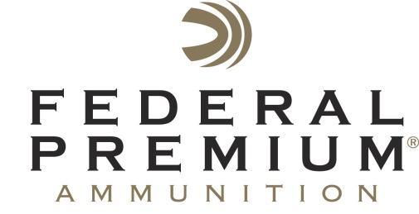
Contact: JJ Reich
Public Relations Specialist
763-323-3862
FOR IMMEDIATE RELEASE E-mail: pressroom@atk.com

Federal Premium Vital-Shok 10mm Auto Trophy Bonded JSP Provides Handgun Hunters with Full-Power Performance

Federal Premium® Vital-Shok™ Trophy Bonded® 10mm Auto is a full-power load that restores the capabilities of the cartridge. With a muzzle velocity of 1,275 fps, the new 180-grain jacketed soft point (JSP) shoots flat and packs a powerful punch in semi-automatic pistols. With ballistics that fall between those of the 357 Magnum and 41 Magnum, the load gives hunters the power to take down deer, bears or hogs.

ANOKA, Minn. – May 6, 2014 – While most commercial 10mm Auto loads offer ballistics comparable to the 40 S&W, the new Vital-Shok™ Trophy Bonded® 10mm Auto from Federal Premium® restores the cartridge to its intended full power. Accurate, powerful and designed to succeed where other rounds have failed, this new load is the perfect choice for semi-automatic handgun hunters.

With a muzzle velocity of 1,275 fps, the 180-grain jacketed soft point (JSP) shoots flat and packs a powerful punch in semi-automatic pistols. With ballistics that fall between those of the 357 Magnum and 41 Magnum, the load gives hunters the power to take down deer, bears or hogs.

The new Trophy Bonded JSP bullet provides optimal terminal performance because it uses some of the proven elements of Federal Premium’s Trophy Bonded® Bear Claw® rifle bullet. The heavy jacket features a formed inner profile that preprograms and controls expansion to ensure deep penetration and high weight retention. A nickel-plated case allows easy and dependable extraction in virtually any 10mm Auto pistol.

New product materials are available in the Online Press Kit on the Vital-Shok 10mm Auto Trophy Bonded page. These materials include two print-ready articles, nine high-resolution photos and more.

Part No. / Description / MSRP
P10T1 / 10mm Auto 180-grain Trophy Bonded JSP / $39.95

For more on Federal Premium, go to www.federalpremium.com.

