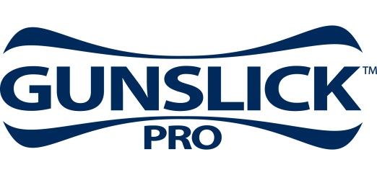

Contact: JJ Reich
Public Relations Specialist
763-323-3862
FOR IMMEDIATE RELEASE E-mail: pressroom@atk.com

Brian ‘Pigman’ Quaca Visits Gunslick Pro at the 2014 SHOT Show

Brian “Pigman” Quaca’s relentless approach to hunting hogs has made his show “Pig Man: The Series” a fan favorite. He’ll visit the Gunslick® Pro booth (#14551) during the 2014 SHOT Show, where he will meet with guests and sign autographs Jan. 15, from 11:00 a.m. to 12:00 p.m. Attendees will also get a chance to check out Gunslick Pro products, including the all-new Ultrasonic Weapons Cleaning Solution. Designed for use with Gunslick’s Ultrasonic Cleaner, the solution quickly removes grease, carbon buildup and fouling from firearm parts. The formulation is non-corrosive and non-combustible.

ANOKA, MN – January 8, 2014 – Brian “Pigman” Quaca’s relentless approach to hunting hogs has made his show “Pig Man: The Series” a fan favorite. He’ll generate that same excitement when he visits the Gunslick® Pro booth (#14551) during the 2014 SHOT Show. Quaca will meet with guests and sign autographs Jan. 15, from 11:00 a.m. to 12:00 p.m.

When you send as many rounds downrange as Pigman, proper firearm cleaning and maintenance is critical. That’s why he chooses from Gunslick Pro’s full array of gun care products to keep his Savage rifles performing to their peak.

Booth guests will get a chance to see all of these products, including the all-new Ultrasonic Weapons Cleaning Solution. Designed for use with Gunslick’s Ultrasonic Cleaner, the solution quickly removes grease, carbon buildup and fouling from firearm parts. The formulation cleans parts inside and out, yet is non-corrosive and non-combustible, making it safe and easy to use.

For more information on Gunslick Pro products, visit www.gunslickpro.com.

