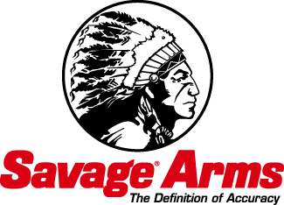
Contact: JJ Reich
Public Relations Specialist
763-323-3862
FOR IMMEDIATE RELEASE E-mail: pressroom@atk.com

Savage Arms Hosts Meet-and-Greets with Brian “Pigman” Quaca at the 2014 NRA Show

Brian “Pigman” Quaca’s relentless approach to hunting hogs has made his show “Pig Man: The Series” a fan favorite. Pigman visits booth #6152 during the 143rd NRA Annual Meeting & Exhibits April 25-27, 2014 in Indianapolis, Ind. He will meet with his fans and sign autographs April 25 from 10:00 a.m. to 11:00 a.m. and again April 26 from 3:30 p.m. to 4:30 p.m. Attendees will also get a chance to see the latest products from Savage® Arms and Gunslick® Pro.

SUFFIELD, CT – April 10, 2014 – Brian “Pigman” Quaca’s relentless approach to hog hunting has made his show “Pig Man: The Series” a fan favorite. Quaca will be making two meet-and-greet appearances at booth #6152 during the 143rd NRA Annual Meeting & Exhibits April 25 to 27, 2014 in Indianapolis, Ind. Pigman will meet with fans and sign autographs April 25 from 10:00 a.m. to 11:00 a.m. and return on April 26 from 3:30 p.m. to 4:30 p.m.

While visiting booth #6152, guests will get a chance to see the latest products from Gunslick® Pro, including the new Ultrasonic Cleaner and accompanying Cleaning Solution. Proper firearm cleaning and maintenance is critical to Pigman’s livelihood. That is why he chooses Gunslick Pro’s gun care products to keep his Savage® rifles performing at their peak.

Attendees of the show are also encouraged to visit the Savage Arms booth (#6045) to check out several new products, including the new Axis II XP. This rifle/scope package offers the same features that make the AXIS so popular, such as a sleek, modern design, silky-smooth bolt, detachable box magazine and a button-rifled barrel. Plus, the AXIS II XP incorporates the now-legendary adjustable Savage AccuTrigger™ and a Weaver® KASPA™ 3-9x40mm scope.

To learn more about Savage Arms and Gunslick Pro, visit www.savagearms.com and www.gunslickpro.com.

