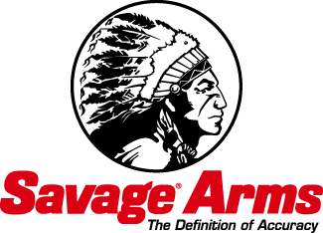
Contact: JJ Reich
Public Relations Specialist
763-323-3862
FOR IMMEDIATE RELEASE E-mail: pressroom@atk.com

Savage Arms, Federal Ammunition Deliver Sure Shot at Savings with $25 Mail-In Rebate Program Currently Underway

Buy a new Savage® Arms centerfire rifle and $50 of qualifying Federal Premium®, Federal® Power•Shok® or Fusion® rifle ammunition and receive $25 via mail-in-rebate. Purchases must be made between October 1 and December 31, 2014. Rebate coupons and complete program details are available online at federalpremium.com.

ANOKA, Minn. – November 4, 2014 – Savage® Arms and Federal® Ammunition deliver hunters and shooters a sure shot at savings with a mail-in rebate program. Available for a limited time to coincide with the hunting and holiday gift-giving seasons, buyers of a new Savage Arms centerfire rifle and $50 worth of qualifying Federal Premium®, Federal Power•Shok® or Fusion® rifle ammunition can receive a $25 rebate.

The Federal/Savage $25 mail-in rebate is available for purchases made between October 1 and December 31, 2014. Purchase of the qualifying ammunition must be made within 30 days of the firearm purchase in order to receive the rebate.

To receive the $25 rebate, purchasers must complete the rebate coupon; submit original UPCs from the rifle box and each box of qualifying ammunition along with the original cash register receipt and/or dated, itemized sales invoice(s). Rebate coupon and proofs of purchase must be received by mail no later than February 13, 2015.

Rebate is limited to one request per name, address and household per offer. Clubs, groups and organization entries are not eligible. Offer valid in the U.S. and Canada; U.S. funds only. For complete details on the $25 Federal Ammunition/Savage Arms Mail-In Rebate and to download the rebate coupon, visit the Federal Premium Ammunition website.

For more on Federal Premium, go to www.federalpremium.com. For more on Savage Arms, go to www.savagearms.com.

