Bolle logo_red

**Contact: Jim Katz**

Breakaway Communications

(860) 538-2461

**FOR IMMEDIATE RELEASE** E-mail: [katz-j@sbcglobal.com](mailto:katz-j@sbcglobal.com)

**BOLLÉ LAUNCHES MICHAEL WADDELL SIGNATURE SERIES CAMOUFLAGE SUNGLASSES**

**OVERLAND PARK, Kansas** – September 17, 2015 – Bollé, a worldwide leader in eyewear, has partnered with Michael Waddell, host of the popular Outdoor Channel program Bone Collector, to offer its first-ever line of camouflage sunglasses. The ten models in this collection feature two of the newest patterns from industry leader Realtree® -- Xtra and Max5.

**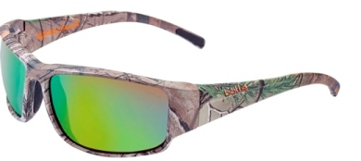**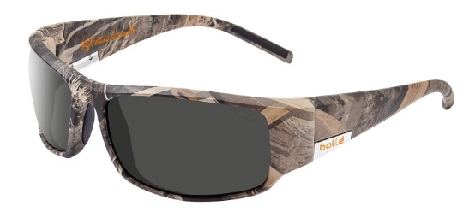

Keelback – Realtree Xtra King – Realtree Max-5

The Bollé Sport Lifestyle collection, the company’s most versatile collection of eyewear, provides the platform for each of the initial Michael Waddell Signature Series styles. Frames are constructed of durable, lightweight B88™ Nylon, and feature Thermogrip® nose pads and temple tips. All lenses are polarized and have an exterior oleophobic/hydrophobic coating, as well as an interior anti-fog treatment.

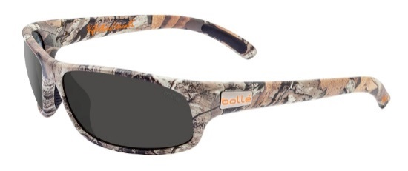 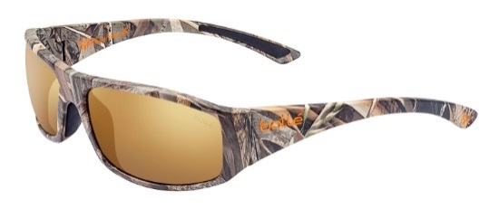

Anaconda – Realtree Xtra Weaver – Realtree Max-5

“Bollé makes authentic gear for outdoor adventures,” noted Bill Yerby, Director of Sales and Marketing for Bollé. “This new camouflage collection fits perfectly into our existing selection of purpose-built eyewear for a range of activities, including cycling, golf and tennis.”

(more)

On retailers’ shelves now, the 10 initial models in the Bollé Michael Waddell Signature Series range in price from $99.99 to $119.99. All models can be fitted with prescription lenses with Bollé’s B-Thin Active Design Rx program.

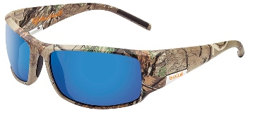 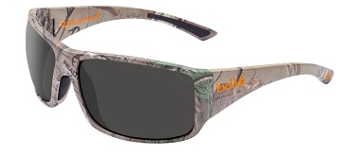

King– Realtree Xtra Tigersnake – Realtree Xtra

Bolléis a brand of Vista Outdoor Inc., an outdoor sports and recreation company. For more information on Bollé, go to [www.bolle.com](http://www.bolle.com).

**About Vista Outdoor Inc.**

Vista Outdoor is a leading global designer, manufacturer and marketer in the growing outdoor sports and recreation markets. The company operates in two segments, Shooting Sports and Outdoor Products, and has more than 30 well-recognized brands that provide consumers with a range of performance-driven, high-quality and innovative products in the ammunition, firearms and outdoor accessories categories. Vista Outdoor products are sold at leading retailers and distributors across North America and worldwide. Vista Outdoor is headquartered in Utah and has manufacturing operations and facilities in 10 U.S. States, Puerto Rico, Mexico and Canada along with international sales and sourcing operations in Canada, Europe, Australia, New Zealand and Asia. For news and information visit www.vistaoutdoor.com or follow us on Twitter @VistaOutdoorInc and Facebook at www.facebook.com/vistaoutdoor.

###