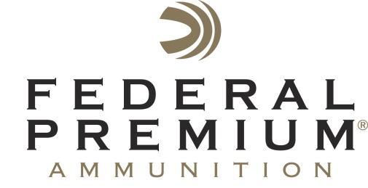
Contact: JJ Reich
Communications Manager
Shooting Sports
763-323-3862
FOR IMMEDIATE RELEASE E-mail: Vistapressroom@vistaoutdoor.com

Federal Premium Showcases New 3rd Degree 20-Gauge Turkey Loads at NWTF Sport Show in Nashville, Feb. 11-14

Federal Premium 3rd Degree Rebate Going Strong

ANOKA, Minnesota – February 10, 2016 – New 3rd Degree 20-gauge turkey loads from Federal Premium will be on display at the 40th Annual National Wild Turkey (NWTF) Convention & Sport Show at the Gaylord Opryland Resort and Convention Center in Nashville, Tennessee, February 11-14. Attendees are encouraged to stop by the Federal Premium booth to learn more about this versatile turkey ammunition.

In addition, a 3rd Degree rebate program is currently underway. With the purchase of any two boxes of 3rd Degree, consumers can receive a free Federal Premium edition Primos pot call. Purchase must be made between January 15, 2016 and May 31, 2016. Learn more at: http://www.federalpremium.com/news/promotions_rebates.aspx.

Last year, Federal Premium redefined how turkey shotshells are supposed to perform with the introduction of 3rd Degree. Rather than simply pattern tightly like conventional loads, 3rd Degree uses a multi-shot, three-stage payload to deliver larger, more forgiving patterns at close range, while still providing deadly performance at long distance. The pattern of No. 5 Premium lead, No. 6 FLITESTOPPER lead and No. 7 HEAVYWEIGHT® shot is maximized by the FLITECONTROL wad, which opens from the rear and stays with the shot column longer than conventional wads for full, consistent patterns. Shipments of this new ammunition are currently being delivered to dealers.

Features & Benefits
- New 20-gauge offering
- Three-stage payload creates optimal patterns for the entire range spectrum
- 20 percent No. 6 FLITESTOPPER pellets for forgiving close-range patterns
- 40 percent copper-plated lead No. 5 shot for lethal performance at mid-range
- 40 percent HEAVYWEIGHT for dense, high-energy patterns at 40-plus yards
- FLITECONTROL wad maximizes the flight characteristics of all three shot types
- A portion of the proceeds are donated to the National Wild Turkey Federation
Part No. / Description / MSRP
PTD258 567 / 3rd Degree, 20-gauge, 1 7/16-ounce / $21.95

Federal Premium is a brand of Vista Outdoor Inc., an outdoor sports and recreation company. For more information on Federal Premium, go to www.federalpremium.com.

About Vista Outdoor Inc.
Vista Outdoor is a leading global designer, manufacturer and marketer in the growing outdoor sports and recreation markets. The company operates in two segments, Shooting Sports and Outdoor Products, and has a portfolio of well-recognized brands that provide consumers with a range of performance-driven, high-quality and innovative products in the ammunition, firearms and outdoor products categories. Vista Outdoor products are sold at leading retailers and distributors across North America and worldwide. Vista Outdoor is headquartered in Utah and has manufacturing operations and facilities in 10 U.S. States, Puerto Rico, Mexico and Canada along with international sales and sourcing operations in Canada, Europe, Australia, New Zealand and Asia. For news and information, visit www.vistaoutdoor.com or follow us on Twitter @VistaOutdoorInc and Facebook at www.facebook.com/vistaoutdoor.

###

