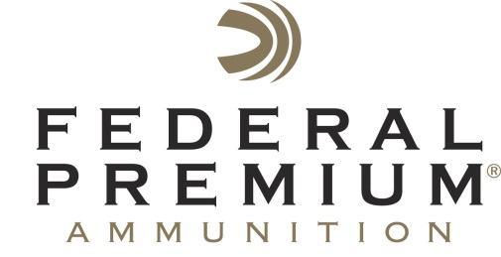
Contact: JJ Reich
Communications Manager
Shooting Sports
763-323-3862
FOR IMMEDIATE RELEASE E-mail: Vistapressroom@vistaoutdoor.com

Federal Premium Earns $227K Grant to Fund Occupation Training Program

ANOKA, Minnesota – September 30, 2015 – Federal Premium and Anoka-Ramsey Community College recently teamed up to earn a $227,712 grant from the Minnesota Job Skills Partnership. The grant process concluded with an official signing event which included city, state, and county officials on Tuesday, September 29 at the entrance to company’s manufacturing facility.

The Minnesota Job Skills Partnership, which promotes cooperative ventures between business, labor and education, is part of the Department of Employment and Economic Development located in Saint Paul, Minnesota. The organization helps fund educational grants to facilitate companies in enhancing the overall skills of the workforce, enhance the work environment and improve leadership at multiple levels.

The grant money will be used to fund an Occupation Training Program at Anoka-Ramsey Community College for Federal Premium Line Leaders, Managers and Supervisors to become efficient and effective at retraining and advancing their workers. The grant will help train 202 employees from June 16, 2015 to June 30, 2017.

“Companies are constantly being challenged to meet growing and changing production demands, competition, and the need to develop a more extensive leadership core,” said Director of Minnesota Job Skills Partnership Paul Moe. “This type of grant has three folds of benefits; first it boosts the overall workforce training levels of those who live in the state, it helps build new curriculum for the community college, and it elevates the productivity and profitability of area businesses, which helps the counties and cities in which they operate and thrive. We are extremely pleased to award this grant to all that are involved.”

“This opportunity not only better develops our employees, it will positively affect our company’s total output now and well into the future. We are excited to implement such a robust program with which to train our employees,” said Federal Premium Organizational Development Specialist and Training Program Director Tom Moreimi. “The training process begins with a train-the-trainer program known as Job Instruction Training; a module of the popular Training Within Industry (TWI) methodology, and a longstanding and proven program within the manufacturing industry.”

The grant certificate signing included Director of Minnesota Job Skills Partnership Paul Moe, Operations Director of Federal Cartridge Company Duane Lowe, Professional & Workforce Training Executive Director for Anoka-Ramsey Community College Jamie Barthel, Anoka County Commissioner Matt Look and City Councilmember Jeff Weaver.

Federal Premium is a brand of Vista Outdoor Inc., an outdoor sports and recreation company. For more information on Federal Premium, go to www.federalpremium.com.

About Vista Outdoor Inc.
Vista Outdoor is a leading global designer, manufacturer and marketer in the growing outdoor sports and recreation markets. The company operates in two segments, Shooting Sports and Outdoor Products, and has more than 30 well-recognized brands that provide consumers with a range of performance-driven, high-quality and innovative products in the ammunition, firearms and outdoor accessories categories. Vista Outdoor products are sold at leading retailers and distributors across North America and worldwide. Vista Outdoor is headquartered in Utah and has manufacturing operations and facilities in 10 U.S. States, Puerto Rico, Mexico and Canada along with international sales and sourcing operations in Canada, Europe, Australia, New Zealand and Asia. For news and information visit www.vistaoutdoor.com or follow us on Twitter @VistaOutdoorInc and Facebook at www.facebook.com/vistaoutdoor.

###

