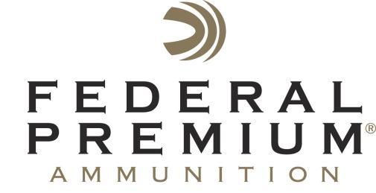
Contact: JJ Reich
Communications Manager
Shooting Sports
763-323-3862
FOR IMMEDIATE RELEASE E-mail: Vistapressroom@vistaoutdoor.com

Shooting Illustrated Honors Federal Premium HST with NRA Golden Bullseye Award

National Rifle Association (NRA) Gives Award to Federal Premium HST

Federal Premium HST Personal Defense Wins Ammunition Product of the Year

ANOKA, Minnesota – April 10, 2015 – The National Rifle Association’s (NRA) Shooting Illustrated magazine has awarded Federal Premium® Personal Defense® HST® with the Golden Bullseye Award for 2015 Ammunition Product of the Year. For the past 13 years, the Golden Bullseye Awards have recognized the finest products in the shooting sports.

Representatives from Federal Premium accepted the award during a special breakfast at the 2015 NRA Annual Meetings & Exhibits on Friday, April 10 in Nashville, Tennessee.

“We are proud to receive the Shooting Illustrated Golden Bullseye Award,” said Federal Premium Ammunition Category Director Rick Stoeckel. “Between this award and the overwhelming market response to HST, we know we are providing a valuable tool for those that demand the best in personal defense ammunition. HST performs to its peak and eliminates any threat.”

The honor highlights the exceptional advantages HST ammunition offers for use in personal protection.

“We are pleased to recognize the winners of the 2015 Golden Bullseye Awards,” said Doug Hamlin, Executive Director of NRA Publications. “This year’s winners exemplify what NRA members want in their shooting equipment—outstanding performance, innovative design and value.”

Federal Premium’s HST offers everything needed in a personal defense round: consistent expansion, optimum penetration and superior terminal performance. It is a trusted duty load for law enforcement officers throughout the world. Its specially designed hollow point won't plug while passing through a variety of barriers, and the bullet jacket and core hold together while penetrating even the toughest materials. HST provides near 100 percent weight retention through most barriers. It is available in 9mm Luger, 40 S&W, 45 Auto and—new for 2015—380 Auto.

Federal Premium is a brand of Vista Outdoor Inc., an outdoor sports and recreation company. For more information on Federal Premium, go to www.federalpremium.com.

About Vista Outdoor Inc.

Vista Outdoor is a leading global designer, manufacturer and marketer in the growing outdoor sports and recreation markets. The company operates in two segments, Shooting Sports and Outdoor Products, and has more than 30 well-recognized brands that provide consumers with a range of performance-driven, high-quality and innovative products in the ammunition, firearms and outdoor accessories categories. Vista Outdoor products are sold at leading retailers and distributors across North America and worldwide. Vista Outdoor is headquartered in Utah and has manufacturing operations and facilities in 10 U.S. States, Puerto Rico, Mexico and Canada along with international sales and sourcing operations in Canada, Europe, Australia, New Zealand and Asia. For news and information visit www.vistaoutdoor.com or follow us on Twitter @VistaOutdoorInc and Facebook at www.facebook.com/vistaoutdoor.

