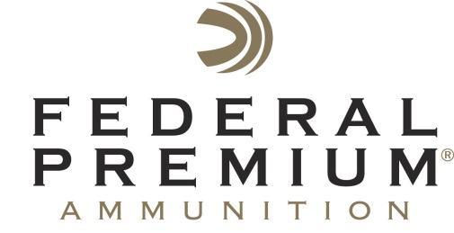
Contact: JJ Reich
Communications Manager
Shooting Sports
763-323-3862
FOR IMMEDIATE RELEASE E-mail: Vistapressroom@vistaoutdoor.com

Federal Premium Announces International Hunter Education Association Volunteer Instructor of the Year

ANOKA, Minnesota – June 15, 2015 – Federal Premium® Ammunition is proud to announce the 2014 International Hunter Education Association (IHEA-USA) Volunteer Instructor of the Year.

Steve Mills of Toledo, Washington earned the distinguished award due to his tremendous contributions in hunter education. In 2014, he taught 32 student classes and certified 800 students. He also taught six new instructor classes, certifying 45 additional hunter education instructors. Additionally, Mills was responsible for developing new teaching aids that are used by instructors all over Washington, and helped develop the online hunter education program in the state.

Federal Premium announced the award on May 21 during the 2015 IHEA-USA Annual Conference in Des Moines Iowa. Steve Mills received the award at a Washington Fish & Wildlife Commission meeting on June 12.

David Whipple, Wildlife Program and Hunter Education Division Manager for the Washington Department of Fish and Wildlife, nominated Mills and an IHEA-USA selection committee named him as a finalist.

“Steve has contributed countless hours to hunter education rivaling the amount of time and substantive contributions of a full-time employee,” said Whipple. “Some of his most valuable contributions are the training and mentoring of new instructors.”

Federal Premium has sponsored the IHEA-USA for more than a decade.

“We sponsor the Instructor of the Year award as a way of recognizing the hunters and shooters who donate their time to pass on our heritage,” said Ryan Bronson, Federal Premium Conservation Director. “Volunteer instructors have always been the lifeblood of hunter education and we thank dedicated instructors, such as Mills, for their tireless efforts to ensure safe hunting and shooting.”

Federal Premium supports numerous conservation organizations, participates in many ammunition royalty programs, and provides a variety of shooting sports educational materials. To learn more about Federal Premium’s support, please visit: http://www.federalpremium.com/education.

Federal Premium is a brand of Vista Outdoor Inc., an outdoor sports and recreation company. For more information on Federal Premium, go to www.federalpremium.com.

For more on IHEA-USA and to learn how you can help support the future of hunting and hunter education, visit www.ihea.com.

About Vista Outdoor Inc.

Vista Outdoor is a leading global designer, manufacturer and marketer in the growing outdoor sports and recreation markets. The company operates in two segments, Shooting Sports and Outdoor Products, and has more than 30 well-recognized brands that provide consumers with a range of performance-driven, high-quality and innovative products in the ammunition, firearms and outdoor accessories categories. Vista Outdoor products are sold at leading retailers and distributors across North America and worldwide. Vista Outdoor is headquartered in Utah and has manufacturing operations and facilities in 10 U.S. States, Puerto Rico, Mexico and Canada along with international sales and sourcing operations in Canada, Europe, Australia, New Zealand and Asia. For news and information visit www.vistaoutdoor.com or follow us on Twitter @VistaOutdoorInc and Facebook at www.facebook.com/vistaoutdoor.

###

