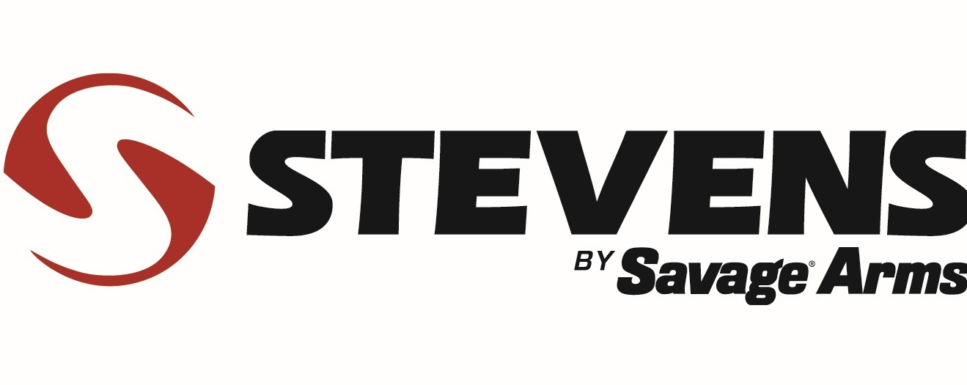
Contact: JJ Reich
Communications Manager
Shooting Sports
763-323-3862
FOR IMMEDIATE RELEASE E-mail: Vistapressroom@vistaoutdoor.com

Stevens Offers 20-Gauge Pump Shotguns for Field or Security

SUFFIELD, Conn. – August 03, 2015 – Stevens has expanded its 320 line with four new 20-gauge models. Two field grade versions—standard and youth—as well as two security models are available. The Stevens 320 pump shotgun series has a reputation for solid, affordable performance for everything from wingshooting to home defense. Shipments of these products are currently being delivered.

The new 20-gauge shotguns boast the same features as their 12-gauge counterparts, with dual slide bars, a rotary bolt, rugged synthetic stock, and five-round magazine. Yet, these lightweight, reliable firearms are priced at or below $260.

Features & Benefits
- Built on the popular 12-gauge model 320 pump shotgun platform
- Dual slide bars
- Rotary bolt
- Rugged synthetic stock
- Five-plus-one capacity

Part No. / Description / MSRP
22436 / Field Grade, 26-inch vent rib barrel / $235
22437 / Youth Field Grade, 22-inch vent rib barrel / $235
22438 / Security, 18 1/2-inch barrel, pistol grip / $260
22439 / Security, 18 1/2-inch barrel, ghost ring, pistol grip / $260

Stevens by Savage Arms™ is a brand of Vista Outdoor Inc., an outdoor sports and recreation company. To learn more about Stevens and Savage Arms, visit www.savagearms.com.

About Vista Outdoor Inc.
Vista Outdoor is a leading global designer, manufacturer and marketer in the growing outdoor sports and recreation markets. The company operates in two segments, Shooting Sports and Outdoor Products, and has more than 30 well-recognized brands that provide consumers with a range of performance-driven, high-quality and innovative products in the ammunition, firearms and outdoor accessories categories. Vista Outdoor products are sold at leading retailers and distributors across North America and worldwide. Vista Outdoor is headquartered in Utah and has manufacturing operations and facilities in 10 U.S. States, Puerto Rico, Mexico and Canada along with international sales and sourcing operations in Canada, Europe, Australia, New Zealand and Asia. For news and information visit www.vistaoutdoor.com or follow us on Twitter @VistaOutdoorInc and Facebook at www.facebook.com/vistaoutdoor.

###

