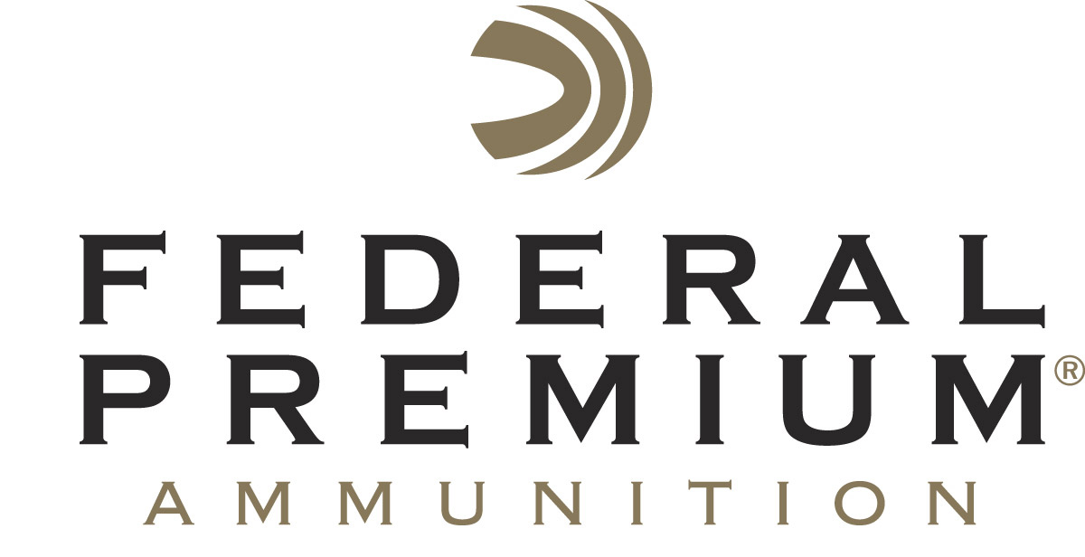
Contact: JJ Reich
Communications Manager
Firearms and Ammunition
(763) 323-3862
FOR IMMEDIATE RELEASE E-mail: pressroom@vistaoutdoor.com

Federal Premium Hosts Shooting Sports Celebrities at
2016 NRA Annual Meetings and Exhibits Show

ANOKA, Minnesota – May 13, 2016 – Federal Premium Ammunition invites attendees of the 2016 NRA Annual Meetings & Exhibits Show to its booth No. 4623 (Vista Outdoor Inc.) in Louisville, Kentucky, May 20-22. Attendees will have the opportunity to meet Federal Premium professional shooter Julie Golob, author Bryce Towsley and famed online personalities “Hickok45” and “22Plinkster.”

Golob is a professional competitive shooter, hunter, author, mother and decorated veteran of the U.S. Army shooting program. She has won more than 120 championship titles in seven different action-shooting disciplines, making her one of the most accomplished shooters in the world. Golob will be in the booth to sign autographs, share shooting tips and answer questions from fans on Friday, May 20 from 2 p.m. to 4 p.m. and Saturday, May 21 from 10 a.m. to 11 a.m.

Hickok45 is a YouTube fan favorite with nearly 2 million subscribers to his channel. His videos have been watched more than 500 million times, and his popularity continues to soar. Hickok45 will be in the booth on Saturday, May 21 from 1 p.m. to 3 p.m. to sign autographs and meet fans.

22Plinkster is also a YouTube fan favorite who entertains his audience with amazing trick shots and rimfire product reviews. He will be in the booth on Saturday, May 21 from 4 p.m. to 5 p.m. and Sunday, May 22 from 3 p.m. to 4 p.m. to sign autographs and meet fans.

Towsley is the acclaimed author of “Prepper Guns.” The book explores guns and related tools needed to survive a variety of disasters. Federal Premium is mentioned frequently in the book, due to its quality, accuracy and reliability. Towsley will be in the booth on Sunday, May 22 from 10 a.m. to 11 a.m. to sign autographs and give away free copies of his book.

Troy, Jacob and Chase Landry (sponsored by Federal Premium’s sister company CCI Ammunition) will also be in booth No. 4623. The Landry family makes their living on the dark and murky waters of the Louisiana swamps. They will be available to answer questions from fans on Saturday, May 21 from 3 p.m. to 4 p.m., and Sunday, May 22 from 2 p.m. to 3 p.m.

Booth No. 4623 will also highlight all the latest products offered by Federal Premium. Attendees are encouraged to stop by throughout the show to learn more about these exciting new technologies and the advantages of choosing Federal Premium Ammunition.

Federal Premium is a brand of Vista Outdoor Inc., an outdoor sports and recreation company. For more information on Federal Premium, go to www.federalpremium.com.

About Vista Outdoor Inc.
Vista Outdoor is a leading global designer, manufacturer and marketer of consumer products in the growing outdoor sports and recreation markets. The company operates in two segments, Shooting Sports and Outdoor Products, and has a portfolio of well-recognized brands that provides consumers with a wide range of performance-driven, high-quality and innovative products for individual outdoor recreational pursuits. Vista Outdoor products are sold at leading retailers and distributors across North America and worldwide. Vista Outdoor is headquartered in Utah and has manufacturing operations and facilities in 13 U.S. States, Canada, Mexico and Puerto Rico along with international customer service, sales and sourcing operations in Asia, Australia, Canada, Europe and New Zealand. For news and information, visit www.vistaoutdoor.com or follow us on Twitter @VistaOutdoorInc and Facebook at www.facebook.com/vistaoutdoor.

###

