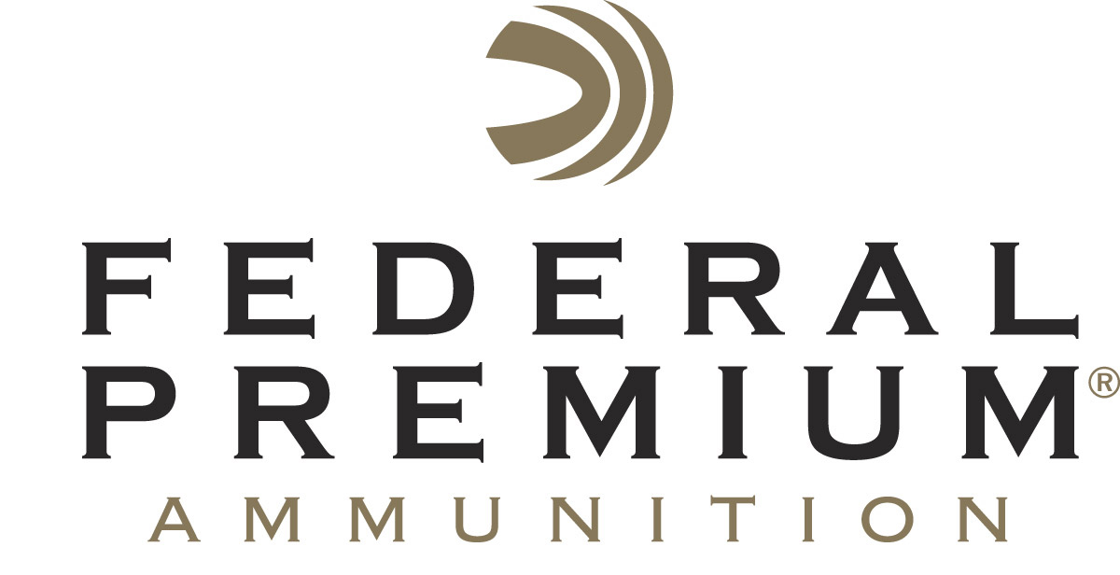
Contact: JJ Reich
Communications Manager
Firearms and Ammunition
(763) 323-3862
FOR IMMEDIATE RELEASE E-mail: pressroom@vistaoutdoor.com

Federal Premium Announced 2016 4-H Leadership Award Winner

ANOKA, Minnesota – July 21, 2016 – Federal Premium Ammunition recently announced the recipient of the sixth annual Bill Stevens 4-H Leadership Award.
Mr. Gerry Snapp from Missouri was recently honored with the award. He was presented with the recognition by Federal’s Director of Conservation Ryan Bronson at the National 4-H Shooting Sports opening ceremonies June 27th in Nebraska.

In 2011, Federal Premium Ammunition created an award to honor those volunteers and professionals involved in the 4-H Shooting Sports Project who have gone the extra mile to achieve the mission of 4-H Shooting Sports.

The award is named after the late Bill Stevens, Federal’s former Conservation Programs Manager who retired in 2007 after 42 years. Stevens played a major role in making the Shooting Sports a part of 4-H across the nation. He also increased Federal’s support of the 4-H program.

Snapp was selected because of his career of service to the 4-H Shooting Sports Project. In his more than 25 years as an extension educator in Kansas and Missouri he spent over 13 years on the National Shooting Sports Committee, hosted two National Championships and has played a pivotal role launching the Western Heritage discipline in recent years.

Federal Premium Ammunition has sponsored 4-H conservation and shooting sports programs for more than 80 years. In addition to sponsoring national competitions, the company was integral in both the formation of 4-H conservation-themed camps in 1934 and the Shooting Sports project in 1976.

4-H Shooting Sports reached over 400,000 children in 2016. Federal Premium has donated more than $440,000 to 4-H Shooting Sports in the last decade, and its lifetime support totals more than $1.2 million.

“Youth development through the shooting sports has been a mission we have shared with 4-H for decades,” said Ryan Bronson. “Professional educators like Gerry are helping to create young citizens that will be tomorrow’s leaders.”

To learn more about 4-H Shooting Sports visit www.4-hshootingsports.org.

Federal Premium is a brand of Vista Outdoor Inc., an outdoor sports and recreation company. For more information on Federal Premium, go to www.federalpremium.com.

Photo Caption: Gerry Snapp Award Winner from Missouri and Ryan Bronson Director of Conservation for Vista Outdoor.

About Vista Outdoor Inc.
Vista Outdoor is a leading global designer, manufacturer and marketer of consumer products in the growing outdoor sports and recreation markets. The company operates in two segments, Shooting Sports and Outdoor Products, and has a portfolio of well-recognized brands that provides consumers with a wide range of performance-driven, high-quality and innovative products for individual outdoor recreational pursuits. Vista Outdoor products are sold at leading retailers and distributors across North America and worldwide. Vista Outdoor is headquartered in Utah and has manufacturing operations and facilities in 13 U.S. States, Canada, Mexico and Puerto Rico along with international customer service, sales and sourcing operations in Asia, Australia, Canada, Europe and New Zealand. For news and information, visit www.vistaoutdoor.com or follow us on Twitter @VistaOutdoorInc and Facebook at www.facebook.com/vistaoutdoor.

###

