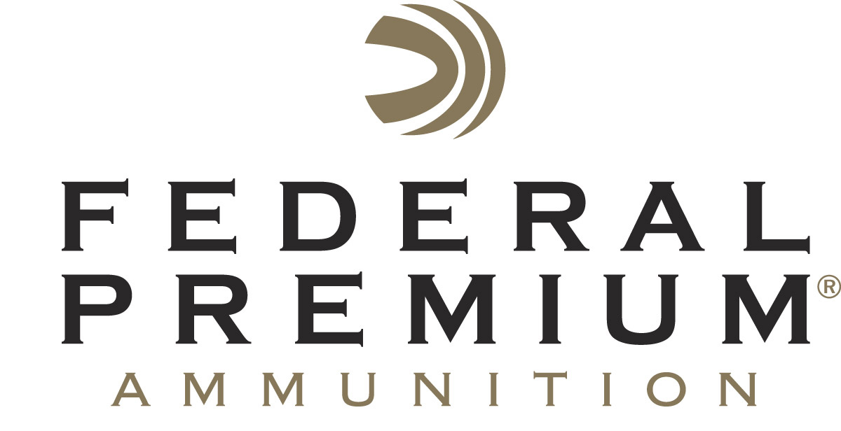
Contact: JJ Reich
Communications Manager
Firearms and Ammunition
(763) 323-3862
FOR IMMEDIATE RELEASE E-mail: pressroom@vistaoutdoor.com

Federal Premium Hosts First-Ever Outdoor Mentoring Summit

Federal Premium Brings Several Hunting and Shooting Organizations From Across Country Together To Collaborate Mentoring Efforts

ANOKA, Minnesota – March 08, 2016 – Federal Premium Ammunition hosted a gathering of 20 leaders from outdoor mentoring programs from across the country March 4-5 at its Anoka, Minnesota facility. Organized in conjunction with the Pass it On Outdoor Mentors organization and the Council to Advance Hunting and Shooting Sports (CAHSS), the two-day meeting was the first attempt to bring a number of local and national organizations together to align their work with the National Hunter Recruitment, Retention and Reactivation (R3) Plan.

“A central part of our commitment to conservation is to attract the next generation of hunters and shooters who are the backbone of conservation funding in America,” said Ryan Bronson, Director of Conservation for Federal Premium Ammunition. “Mentoring programs are helping the hunting conservation community reach a diverse population that includes at-risk kids, urbanites and females who traditionally are under-represented.”

State wildlife agencies from Minnesota, Arizona and Nebraska provided information on government efforts. Private mentoring groups from Pennsylvania, Wisconsin, Indiana, Minnesota, South Dakota, Kansas and Idaho also participated, offering their perspectives from an array of backgrounds. The National Wild Turkey Federation offered its input as a national organization dedicated to the effort. The meeting was facilitated by Bob Byrne Consulting.

The National R3 plan has been developed over several years with the cooperation of wildlife agencies, non-profit hunting and conservation organizations, and the shooting sports industry. The Wildlife Management Institute and CAHSS have led the effort, and their draft plan will be released at the North American Wildlife and Natural Resources Conference in Pittsburgh Wednesday March 16.

“There are literally hundreds of programs that are doing good work on R3 efforts around the country, and gatherings like the one hosted by Federal are helping us coalesce around a common vision,” said John Frampton, CEO of CAHSS. “The common vision, best practices and means to evaluate progress can be found in the R3 plan.”

Federal Premium is a brand of Vista Outdoor Inc., an outdoor sports and recreation company. For more information on Federal Premium, go to www.federalpremium.com.

About Vista Outdoor Inc.
Vista Outdoor is a leading global designer, manufacturer and marketer in the growing outdoor sports and recreation markets. The company operates in two segments, Shooting Sports and Outdoor Products, and has a portfolio of well-recognized brands that provide consumers with a range of performance-driven, high-quality and innovative products in the ammunition, firearms and outdoor products categories. Vista Outdoor products are sold at leading retailers and distributors across North America and worldwide. Vista Outdoor is headquartered in Utah and has manufacturing operations and facilities in 10 U.S. States, Puerto Rico, Mexico and Canada along with international sales and sourcing operations in Canada, Europe, Australia, New Zealand and Asia. For news and information, visit www.vistaoutdoor.com or follow us on Twitter @VistaOutdoorInc and Facebook at www.facebook.com/vistaoutdoor.

###

