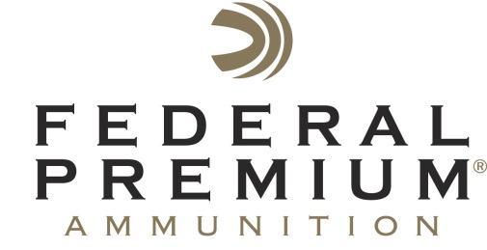
Contact: JJ Reich
Communications Manager
Shooting Sports
763-323-3862
FOR IMMEDIATE RELEASE E-mail: Vistapressroom@vistaoutdoor.com

Federal Premium Surpasses 50 Million Rounds to Support Pheasants Forever’s Conservation Mission

Federal Premium Ammunition Continues Its Pheasants Forever Royalty Program for Upland Hunting Shotgun Shells

ANOKA, Minn. – October 26, 2016 – Federal Premium is proud to announce it has surpassed a total of 50 million shotgun shells sold in support of Pheasants Forever, the nation’s leading upland habitat conservation organization. These special shells are all sold in boxes marked with the Pheasants Forever logo, as part of an on-box royalty program.

Federal Premium and Pheasants Forever’s on-box royalty program began in 1998 with Federal Premium’s Pheasants Forever-labeled Wing-Shok shotgun shell boxes. The program evolved in 2010 with the revolutionary Prairie Storm specialty pheasant load, and it continued to grow in 2011 with the introduction of Prairie Storm FS Steel. A portion of the proceeds from each Pheasants Forever logoed box sold goes directly to the conservation group’s wildlife habitat efforts, contributing to sustainable pheasant populations and increased upland hunter participation.

“Protecting, restoring and enhancing habitat is critical for pheasants and all wildlife,” said Ryan Bronson, Director of Conservation for Federal Premium Ammunition. “The forethought that leaders within our company and Pheasants Forever had in creating this successful funding mechanism needs to be celebrated.”

All firearms and ammunition sold in the United States contribute to conservation through the 11 percent federal Pittman Robertson excise tax. Federal Premium’s parent company Vista Outdoor paid $83.9 million to that fund in fiscal year 2016. This on-the-box royalty program is a voluntary contribution that is above and beyond the tax, and reflects the company’s commitment to conservation.

“The on-box royalty program created between Federal Premium Ammunition and Pheasants Forever has contributed immensely to the organization’s 14.1 million acres of wildlife habitat conservation impacts,” stated Howard Vincent, president and CEO of Pheasants Forever, Inc. “Pheasants Forever encourages its members and all upland hunters to purchase Wing-Shok and Prairie Storm ammunition in an effort to reach the next milestone of 100 million rounds, while continuing to support one of the finest conservation partnerships in North America.”

Pheasants Forever, including its quail conservation division, Quail Forever, is the nation's largest nonprofit organization dedicated to upland habitat conservation. For more information, go to www.pheasantsforever.org.

Federal Premium is a brand of Vista Outdoor Inc., an outdoor sports and recreation company. For more information on Federal Premium, go to www.federalpremium.com.

About Vista Outdoor Inc.
Vista Outdoor is a leading global designer, manufacturer and marketer of consumer products in the growing outdoor sports and recreation markets. The company operates in two segments, Shooting Sports and Outdoor Products, and has a portfolio of well-recognized brands that provides consumers with a wide range of performance-driven, high-quality and innovative products for individual outdoor recreational pursuits. Vista Outdoor products are sold at leading retailers and distributors across North America and worldwide. Vista Outdoor is headquartered in Utah and has manufacturing operations and facilities in 13 U.S. States, Canada, Mexico and Puerto Rico along with international customer service, sales and sourcing operations in Asia, Australia, Canada, Europe and New Zealand. For news and information, visit www.vistaoutdoor.com or follow us on Twitter @VistaOutdoorInc and Facebook at www.facebook.com/vistaoutdoor.

###

