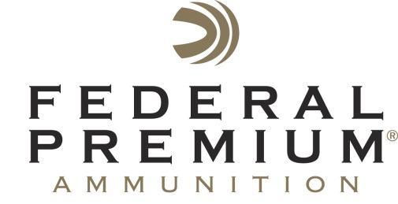
Contact: JJ Reich
Communications Manager
Shooting Sports
763-323-3862
FOR IMMEDIATE RELEASE E-mail: Vistapressroom@vistaoutdoor.com

Federal Premium Launches Special One-Month Cash-Back Rebate On Its Most Effective Big Game Ammunition

Several Federal Premium, Federal Power-Shok and Fusion Ammunition Cash-Back Rebate Programs Currently Running Strong

ANOKA, Minn. – September 6, 2016 – Federal Premium announced its launch of a special one-month offer for cash back on its most effective big-game hunting loads. Customers can now get as much as $20 cash back when they purchase up to two boxes of Trophy Bonded Tip or any other Federal Premium Vital-Shok rifle ammunition through the month of September 2016.

The ammunition purchase must be made between September 1, 2016 and September 30, 2016. See the back of the rebate coupon for full details and conditions. To download and view this coupon, visit www.federalpremium.com/news/promotions_rebates.aspx.

The company has several other rebate offers running through December 31, 2016.
- Big Buck Slug Rebate: Receive up to $10.00 cash back when you purchase qualifying Federal Premium Vital-Shok slug ammunition.
- Drop Ducks Like Rain Rebate: Get up to $110 back when you buy Black Cloud waterfowl ammunition by the case.
- Shoot Bucks, Save Bucks Rebate: Purchase up to two boxes of any Power-Shok rifle loads and receive up to a $5.00 mail-in rebate.
- Take 5 with Fusion: Purchase up to two boxes of any Fusion rifle loads and receive up to a $5.00 mail-in rebate. Additional rebate offers are also available.

For full details and downloadable coupons for all of these promotions, visit www.federalpremium.com/news/promotions_rebates.aspx.

Federal Premium is a brand of Vista Outdoor Inc., an outdoor sports and recreation company. For more information on Federal Premium, go to www.federalpremium.com.

About Vista Outdoor Inc.
Vista Outdoor is a leading global designer, manufacturer and marketer of consumer products in the growing outdoor sports and recreation markets. The company operates in two segments, Shooting Sports and Outdoor Products, and has a portfolio of well-recognized brands that provides consumers with a wide range of performance-driven, high-quality and innovative products for individual outdoor recreational pursuits. Vista Outdoor products are sold at leading retailers and distributors across North America and worldwide. Vista Outdoor is headquartered in Utah and has manufacturing operations and facilities in 13 U.S. States, Canada, Mexico and Puerto Rico along with international customer service, sales and sourcing operations in Asia, Australia, Canada, Europe and New Zealand. For news and information, visit www.vistaoutdoor.com or follow us on Twitter @VistaOutdoorInc and Facebook at www.facebook.com/vistaoutdoor.

###

