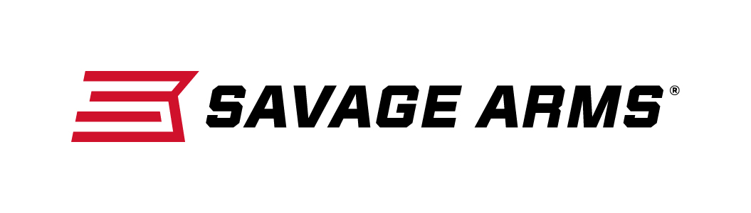
Contact: JJ Reich
Communications Manager
Firearms and Ammunition
(763) 323-3862
FOR IMMEDIATE RELEASE E-mail: pressroom@vistaoutdoor.com

Savage Arms Delivers Quality and Affordability with its
11 DOA Hunter XP Scoped Rifle Package

SUFFIELD, Connecticut – November 29, 2016 – Savage Arms is pleased to announce a lineup of 15 new scoped-rifle packages featuring Bushnell Trophy Scopes with DOA reticle, priced less than $685. Shipments of these firearms are currently being delivered to dealers.

The combo features a factory-mounted and bore-sighted Bushnell Trophy scope on a model 11 rifle. Trophy riflescopes have been heralded by hunters as the ideal scope for deer in heavily wooded areas. The specialized, drop-compensating Bushnell DOA reticle can be utilized with different ballistics.

The rifle package is built to provide a lifetime of reliable performance thanks to its legendary Savage 110 action, floating bolt head, and thread-in, zero-tolerance headspace system. The rifle also features a button-rifled barrel, detachable box magazine and user-adjustable AccuTrigger. Savage offers the package in fifteen popular calibers to give young shooters options to pursue everything from varmints to big game.

Features & Benefits
- Detachable Box Magazine
- Black Synthetic Stock
- Matte Blued Barrel
- Weaver Grand Slam Rings

Bushnell Trophy Scope Specifications
- Fast Focus Eyepiece
- Finger Touch Adjustable Windage & Elevation Controls
- Shooter Visible Power Change Ring
- DOA drop-compensating reticle

The right-handed rifle weighs 7.25 to 8.25 pounds, depending on caliber, and holds four rounds. It has barrel length of 22 inches with an overall length of 41.5 inches. Rate-of-twist ranges from 1-in-9 inches to 1-in-12 inches, depending on caliber.

Part No. / Description / MSRP
22600 / 11 DOA Hunter XP 243 WIN. / $684
22601 / 11 DOA Hunter XP 6.5 CREEDMOOR / $684
22602 / 11 DOA Hunter XP 7MM08 REM. / $684
22603 / 11 DOA Hunter XP 260 REM. / $684
22604 / 11 DOA Hunter XP 308 WIN. / $684
22605 / 11 DOA Hunter XP 270 WSM / $712
22606 / 11 DOA Hunter XP 300 WSM / $712
22607 / 11 DOA Hunter XP 338 FEDERAL / $684
22608 / 111 DOA Hunter XP 2506 REM. / $684
22609 / 111 DOA Hunter XP 6.5 X 284 NORMA / $684
22610 / 111 DOA Hunter XP 270 WIN. / $684
22611 / 111 DOA Hunter XP 3006 SPFLD. / $684
22612 / 111 DOA Hunter XP 7MM REM. MAG. / $684
22613 / 111 DOA Hunter XP 300 WIN. MAG. / $684
22614 / 111 DOA Hunter XP 338 WIN. MAG. / $684

Savage Arms is a brand of Vista Outdoor Inc., an outdoor sports and recreation company. To learn more about Savage Arms, visit www.savagearms.com.

About Vista Outdoor Inc.
Vista Outdoor is a leading global designer, manufacturer and marketer of consumer products in the growing outdoor sports and recreation markets. The company operates in two segments, Shooting Sports and Outdoor Products, and has a portfolio of well-recognized brands that provides consumers with a wide range of performance-driven, high-quality and innovative products for individual outdoor recreational pursuits. Vista Outdoor products are sold at leading retailers and distributors across North America and worldwide. Vista Outdoor is headquartered in Utah and has manufacturing operations and facilities in 13 U.S. States, Canada, Mexico and Puerto Rico along with international customer service, sales and sourcing operations in Asia, Australia, Canada, Europe and New Zealand. For news and information, visit www.vistaoutdoor.com or follow us on Twitter @VistaOutdoorInc and Facebook at www.facebook.com/vistaoutdoor.

###

