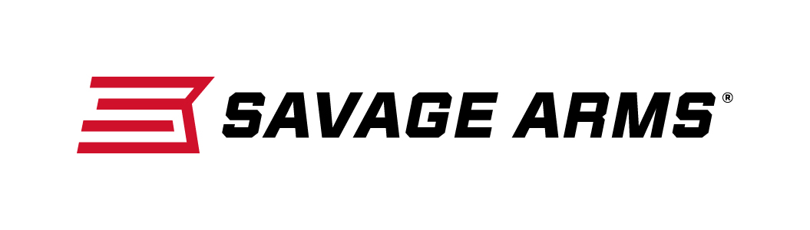
Contact: JJ Reich
Communications Manager
Firearms and Ammunition
(763) 323-3862
FOR IMMEDIATE RELEASE E-mail: pressroom@vistaoutdoor.com

Savage Arms Offers Several Rifle Configurations in the Popular 338 Federal Caliber

SUFFIELD, Conn. – September 30, 2016 – Since its introduction in 2006, the 338 Federal has established itself has an extremely versatile, high-performance big game cartridge. These qualities have inspired Savage Arms to chamber six of its most popular big game rifles in the caliber. They include the 11 Long Range Hunter, 11 Hog Hunter, 16 FCSS, 16 Bear Hunter, 11 Trophy Hunter XP and 16 Trophy Hunter XP. These firearm options are currently shipping to dealers.

Built on the .308 case and “necked-up” to hold a .338 diameter bullet, this load offers hunters a faster muzzle velocity than the 308 Win. but with a heavier bullet. As a result, the short-action cartridge provides magnum energy for devastating performance on game, without magnum recoil.

Features & Benefits
- Short-action 338 Federal chambering
- Higher muzzle velocity than the 308 Win. with a .338 diameter bullet
- Devastating terminal performance with less felt recoil than typical magnum calibers
- Available in six of Savage Arms’ most popular big game rifle platforms

Part No. / Description / MSRP
22450 / 11 Long Range Hunter, 338 Federal / $1,104
22455 / 11 Hog Hunter, 338 Federal / $560
22453 / 16 FCSS, 338 Federal / $885
22454 / 16 Bear Hunter, 338 Federal / $1,035
22451 / 11 Trophy Hunter XP, 338 Federal / $612
22452 / 16 Trophy Hunter XP, 338 Federal / $740

Savage Arms is a brand of Vista Outdoor Inc., an outdoor sports and recreation company. For more information and to get technical specifications on these firearms, visit savagearms.com.

About Vista Outdoor Inc.
Vista Outdoor is a leading global designer, manufacturer and marketer of consumer products in the growing outdoor sports and recreation markets. The company operates in two segments, Shooting Sports and Outdoor Products, and has a portfolio of well-recognized brands that provides consumers with a wide range of performance-driven, high-quality and innovative products for individual outdoor recreational pursuits. Vista Outdoor products are sold at leading retailers and distributors across North America and worldwide. Vista Outdoor is headquartered in Utah and has manufacturing operations and facilities in 13 U.S. States, Canada, Mexico and Puerto Rico along with international customer service, sales and sourcing operations in Asia, Australia, Canada, Europe and New Zealand. For news and information, visit www.vistaoutdoor.com or follow us on Twitter @VistaOutdoorInc and Facebook at www.facebook.com/vistaoutdoor.

###

