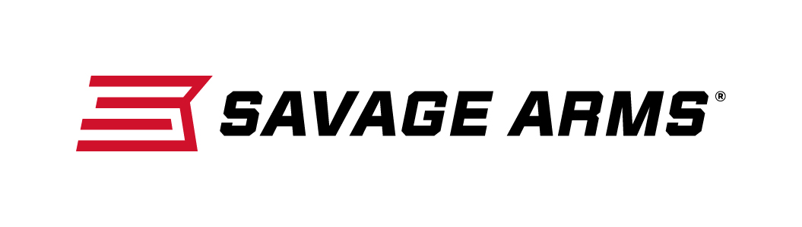
Contact: JJ Reich
Communications Manager
Firearms and Ammunition
(763) 323-3862
FOR IMMEDIATE RELEASE E-mail: pressroom@vistaoutdoor.com

Stevens Adds Four Enhanced Over-Under Shotguns to its 555 Lineup

SUFFIELD, Connecticut – November 30, 2016 – Savage Arms is pleased to announce its extension of 555 over-under shotgun product line by adding four upgraded and laser engraved models priced less than $865. Shipments of these firearms are currently being delivered to dealers.

Stevens has dovetailed performance and value in its new 555 over-under shotgun. Its light aluminum receiver is scaled to gauge and incorporates a steel insert that reinforces the breech, minimizing weight and maximizing strength. The fast-handling 555 Enhanced features upgrades that include Imperial walnut stock and forearm, auto shell ejector and laser-engraved Filigree ornament receiver.

Standard features include a manual safety, and a single, selective mechanical trigger, and more—at a price that’s unmatched among comparable over-under shotguns. Five interchangeable choke tubes allow the 555 to meet any shooting need.

Features & Benefits
- Auto ejector
- Imperial Walnut stock and forearm
- Laser engraved Filigree ornament
- 5 interchangeable chokes
- Lightweight alloy receiver
- Single selective mechanical triggers
- Chrome-lined barrels
- Tang-mounted safety

Specifications
- 12-gauge: 28-inch barrels, 14 3/8-inch length of pull, 44 7/8-inch overall length, 2 1/8-inch drop at comb, 6 pounds
- 20-gauge specifications: 26-inch barrels, 14 3/8-inch length of pull, 42 7/8-inch overall length, 2 1/4-inch drop at comb, 5 1/2 pounds
- 28-gauge specifications: 26-inch barrels, 14 3/8-inch length of pull, 42 7/8-inch overall length, 2 1/4-inch drop at comb, 5 1/2 pounds
- 410-bore specifications: 26-inch barrels, 14 3/8-inch length of pull, 42 7/8-inch overall length, 2 1/4-inch drop at comb, 5 1/2 pounds

Part No. / Description / MSRP
22592 / Stevens 555 12-gauge, 2 3/4- to 3-inch chamber / $863.00
22593 / Stevens 555 20-gauge, 2 3/4- to 3-inch chamber / $863.00
22594 / Stevens 555 28-gauge, 2 3/4- to 3-inch chamber / $863.00
22595 / Stevens 555 .410 Bore, 2 1/2- to 3-inch chamber / $863.00

Stevens by Savage Arms is a brand of Vista Outdoor Inc., an outdoor sports and recreation company. To learn more about Savage Arms, visit www.savagearms.com.

About Vista Outdoor Inc.
Vista Outdoor is a leading global designer, manufacturer and marketer of consumer products in the growing outdoor sports and recreation markets. The company operates in two segments, Shooting Sports and Outdoor Products, and has a portfolio of well-recognized brands that provides consumers with a wide range of performance-driven, high-quality and innovative products for individual outdoor recreational pursuits. Vista Outdoor products are sold at leading retailers and distributors across North America and worldwide. Vista Outdoor is headquartered in Utah and has manufacturing operations and facilities in 13 U.S. States, Canada, Mexico and Puerto Rico along with international customer service, sales and sourcing operations in Asia, Australia, Canada, Europe and New Zealand. For news and information, visit www.vistaoutdoor.com or follow us on Twitter @VistaOutdoorInc and Facebook at www.facebook.com/vistaoutdoor.

###

