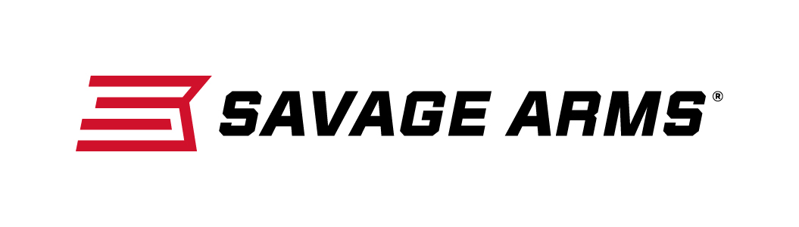
Contact: JJ Reich
Communications Manager
Firearms and Ammunition
(763) 323-3862
FOR IMMEDIATE RELEASE E-mail: pressroom@vistaoutdoor.com

Savage Arms Adds Target and Sporter Models to Its A17 17 HMR Lineup

SUFFIELD, Connecticut – October 4, 2016 – Savage Arms is pleased to announce its launch of the A17 17 HMR in heavy barrel / target stock configurations. These new models feature heavy barrels and/or gray wood laminate stocks for updated styling and increased accuracy. Shipments of these new rifles are being delivered to dealers.

The A17 platform is the first high-performance semi-automatic rimfire specifically designed for the 17 HMR cartridge, and its unique delayed-blowback action provides safe, reliable operation with standard 17 HMR loads. Standard features such as a hard chrome bolt, case-hardened receiver, 10-round rotary magazine and button-rifled barrel boost performance even further, while the user-adjustable AccuTrigger™ provides a crisp, light pull for the best possible accuracy.

Features & Benefits
- First reliable semi-automatic rimfire specifically designed from for 17 HMR
- Delayed-blowback action ensures safe, reliable cycling
- Hard chrome bolt with oversized bolt handle
- Case-hardened receiver and 22-inch button-rifled barrel
- 10-round rotary magazine
- User-adjustable AccuTrigger

Part No. / Description / MSRP
47005 / A17 Target Sporter Thumbhole (Bull Barrel/Laminate Stock), 17 HMR / $631
47006 / A17 Target Sporter (Bull Barrel/Laminate Stock), 17 HMR / $571
47008 / A17 Sporter (Standard Barrel/Laminate Stock), 17 HMR / $554

Savage Arms is a brand of Vista Outdoor Inc., an outdoor sports and recreation company. To learn more about Savage Arms, visit www.savagearms.com.
About Vista Outdoor Inc.
Vista Outdoor is a leading global designer, manufacturer and marketer of consumer products in the growing outdoor sports and recreation markets. The company operates in two segments, Shooting Sports and Outdoor Products, and has a portfolio of well-recognized brands that provides consumers with a wide range of performance-driven, high-quality and innovative products for individual outdoor recreational pursuits. Vista Outdoor products are sold at leading retailers and distributors across North America and worldwide. Vista Outdoor is headquartered in Utah and has manufacturing operations and facilities in 13 U.S. States, Canada, Mexico and Puerto Rico along with international customer service, sales and sourcing operations in Asia, Australia, Canada, Europe and New Zealand. For news and information, visit www.vistaoutdoor.com or follow us on Twitter @VistaOutdoorInc and Facebook at www.facebook.com/vistaoutdoor.

###

