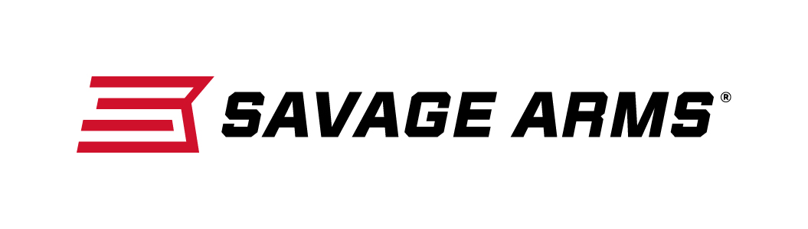
Contact: JJ Reich
Communications Manager
Firearms and Ammunition
(763) 323-3862
FOR IMMEDIATE RELEASE E-mail: pressroom@vistaoutdoor.com

Savage Arms Introduces A17 17 HMR Scoped Package Featuring Bushnell A17 riflescope

SUFFIELD, Connecticut – July 12, 2016 – Savage Arms is pleased to announce its launch of a new A17 XP scope-package gun. The new A17 XP model features a Bushnell A17 scope that comes mounted and boresighted, making it easier than ever for shooters to get from the store to the field or range. Shipments of this new rifle are being delivered to dealers.

Savage Arms made firearms history when it introduced the A17 in 2015. The platform is the first high-performance semi-automatic rimfire specifically designed for the 17 HMR cartridge, and its unique delayed-blowback action provides safe, reliable operation with standard 17 HMR loads.

Features & Benefits
- First reliable semi-automatic rimfire platform designed for 17 HMR
- Bushnell A17 riflescope, mounted and boresighted
- Delayed-blowback action ensures safe, reliable cycling
- Hard chrome bolt with oversized bolt handle
- Case-hardened receiver and 22-inch button-rifled barrel
- 10-round rotary magazine
- User-adjustable AccuTrigger™

Part No. / Description / MSRP
47011 / A17 XP package rifle, 17 HMR / $578

Savage Arms is a brand of Vista Outdoor Inc., an outdoor sports and recreation company. To learn more about Savage Arms, visit www.savagearms.com.

About Vista Outdoor Inc.
Vista Outdoor is a leading global designer, manufacturer and marketer of consumer products in the growing outdoor sports and recreation markets. The company operates in two segments, Shooting Sports and Outdoor Products, and has a portfolio of well-recognized brands that provides consumers with a wide range of performance-driven, high-quality and innovative products for individual outdoor recreational pursuits. Vista Outdoor products are sold at leading retailers and distributors across North America and worldwide. Vista Outdoor is headquartered in Utah and has manufacturing operations and facilities in 13 U.S. States, Canada, Mexico and Puerto Rico along with international customer service, sales and sourcing operations in Asia, Australia, Canada, Europe and New Zealand. For news and information, visit www.vistaoutdoor.com or follow us on Twitter @VistaOutdoorInc and Facebook at www.facebook.com/vistaoutdoor.

###

