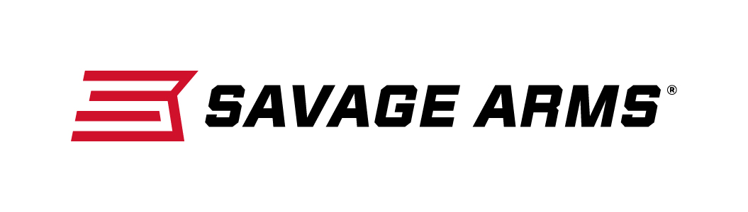
Contact: JJ Reich
Communications Manager
Firearms and Ammunition
(763) 323-3862
FOR IMMEDIATE RELEASE E-mail: pressroom@vistaoutdoor.com

Savage Arms Offers its AXIS II in Stainless and Hardwood Options

SUFFIELD, Conn. – September 29, 2016 – The AXIS II package rifle is the perfect way for shooters to go from the store to the field, with everything you need at an affordable price. Savage Arms has added to the series with new stainless barrel and hardwood stock options. Caliber options include the popular 6.5 Creedmoor. These options are currently shipping to dealers.

The AXIS II is built on the best-selling AXIS rifle platform with several significant performance-enhancing features. It sports the legendary adjustable AccuTrigger system for optimized accuracy and allows customization to your individual preference and shooting style. The addition of the premium quality, mounted and boresighted Weaver KASPA 3-9x40mm riflescope allows you to confidently hunt in all conditions.

Features & Benefits
- Sleek, modern design
- Includes Weaver KASPA 3-9x40mm scope
- Silky-smooth bolt action and button rifled barrel
- Four-round detachable box magazine
- Adjustable Savage AccuTrigger
- Black synthetic stock with stainless steel barrel
- Hardwood stock with blued barrel

Part No. / Description / MSRP
22541 / AXIS II XP Stainless / 223 Rem. / $580.00
22542 / AXIS II XP Stainless / 22-250 Rem. / $580.00
22543 / AXIS II XP Stainless / 243 Win. / $580.00
22677 / AXIS II XP Stainless / 6.5 Creedmoor / $580.00
22544 / AXIS II XP Stainless / 7mm-08 Rem. / $580.00
22545 / AXIS II XP Stainless / 308 Win. / $580.00
22546 / AXIS II XP Stainless / 25-06 Rem. / $580.00
22547 / AXIS II XP Stainless / 270 Win. / $580.00
22548 / AXIS II XP Stainless / 30-06 Spfld. / $580.00
22549 / AXIS II XP Hardwood / 223 Rem. / $506.00
22550 / AXIS II XP Hardwood / 22-250 Rem. / $506.00
22551 / AXIS II XP Hardwood / 243 Win. / $506.00
22678 / AXIS II XP Hardwood / 6.5 Creedmoor / $506.00
22552 / AXIS II XP Hardwood / 7mm-08 Rem. / $506.00
22553 / AXIS II XP Hardwood / 308 Win. / $506.00
22554 / AXIS II XP Hardwood / 25-06 Rem. / $506.00
22555 / AXIS II XP Hardwood / 270 Win. / $506.00
22556 / AXIS II XP Hardwood / 30-06 Spfld. / $506.00

Savage Arms is a brand of Vista Outdoor Inc., an outdoor sports and recreation company. For more information and to get technical specifications on these firearms, visit savagearms.com.

About Vista Outdoor Inc.
Vista Outdoor is a leading global designer, manufacturer and marketer of consumer products in the growing outdoor sports and recreation markets. The company operates in two segments, Shooting Sports and Outdoor Products, and has a portfolio of well-recognized brands that provides consumers with a wide range of performance-driven, high-quality and innovative products for individual outdoor recreational pursuits. Vista Outdoor products are sold at leading retailers and distributors across North America and worldwide. Vista Outdoor is headquartered in Utah and has manufacturing operations and facilities in 13 U.S. States, Canada, Mexico and Puerto Rico along with international customer service, sales and sourcing operations in Asia, Australia, Canada, Europe and New Zealand. For news and information, visit www.vistaoutdoor.com or follow us on Twitter @VistaOutdoorInc and Facebook at www.facebook.com/vistaoutdoor.

###

