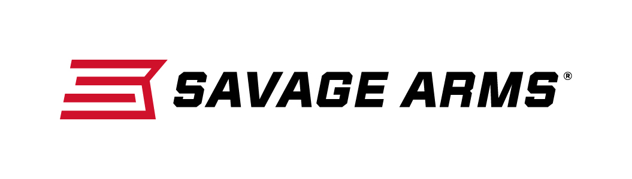
Contact: JJ Reich
Communications Manager
Firearms and Ammunition
(763) 323-3862
FOR IMMEDIATE RELEASE E-mail: pressroom@vistaoutdoor.com

Savage Arms Introduces New B-Series Bolt Action Rimfire Rifles

SUFFIELD, Connecticut – December 14, 2016 – Savage Arms is pleased to introduce a new line of bolt-action rimfire rifles with its new B-Series, including 12 caliber options priced from $281 to $413. Shipments of these firearms are currently being delivered to dealers.

Savage has added to its line of modern new firearms with the B17, B22 and B22 Magnum bolt-action rimfire rifles. The new models’ ergonomically designed stock, higher comb, top tang safety and target-style, vertical pistol grip allow shooters to hold the rifle in a more natural position that puts less pressure on the wrist.

The B Series includes a dozen new models in configurations including Sporter Barrel, Heavy Barrel, Heavy Threaded (suppressor ready) and Heavy Stainless. Like the popular A Series rimfires, all B Series rifles feature a 10-round rotary magazine and the accuracy-boosting adjustable AccuTrigger.

Features & Benefits
- Four configurations available in 22 LR, 22 WMR and 17 HMR
- User-adjustable AccuTrigger
- 10-round rotary magazine
- Button-rifled barrel
- Modern, ergonomic composite stock
- Top tang safety
- Drilled and tapped for scope mounts

Part No. / Description / MSRP
70200 / B22 F, 22 LR / $281.00
70201 / B22 FV, 22 LR / $308.00
70202 / B22 FVSS, 22 LR / $392.00
70203 / B22 FV-SR, 22 LR / $344.00
70500 / B22 Magnum F, 22 WMR / $301.00
70501 / B22 Magnum FV, 22 WMR / $329.00
70502 / B22 Magnum FVSS, 22 WMR / $413.00
70503 / B22 Magnum FV-SR, 22 WMR / $364.00
70800 / B17 F, 17 HMR / $301.00
70801 / B17 FV, 17 HMR / $329.00
70802 / B17 FVSS, 17 HMR / $413.00
70803 / B17 FV-SR, 17 HMR / $364.00

Savage Arms is a brand of Vista Outdoor Inc., an outdoor sports and recreation company. To learn more about Savage Arms, visit www.savagearms.com.

About Vista Outdoor Inc.
Vista Outdoor is a leading global designer, manufacturer and marketer of consumer products in the growing outdoor sports and recreation markets. The company operates in two segments, Shooting Sports and Outdoor Products, and has a portfolio of well-recognized brands that provides consumers with a wide range of performance-driven, high-quality and innovative products for individual outdoor recreational pursuits. Vista Outdoor products are sold at leading retailers and distributors across North America and worldwide. Vista Outdoor is headquartered in Utah and has manufacturing operations and facilities in 13 U.S. States, Canada, Mexico and Puerto Rico along with international customer service, sales and sourcing operations in Asia, Australia, Canada, Europe and New Zealand. For news and information, visit www.vistaoutdoor.com or follow us on Twitter @VistaOutdoorInc and Facebook at www.facebook.com/vistaoutdoor.

###

