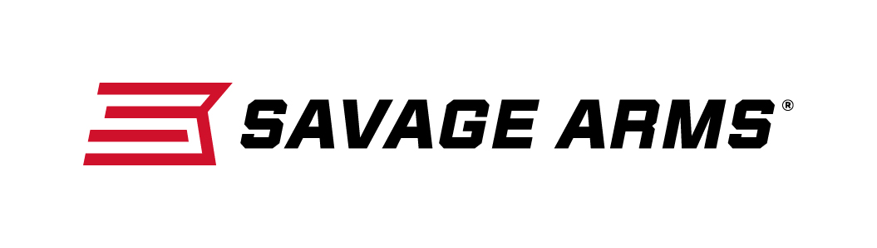
Contact: JJ Reich
Communications Manager
Firearms and Ammunition
(763) 323-3862
FOR IMMEDIATE RELEASE E-mail: pressroom@vistaoutdoor.com

Savage Arms Launches Its Model 42 Takedown at the 2016 SHOT Show

SUFFIELD, Connecticut – January 18, 2016 – Savage Arms is pleased to announce its launch of a new Model 42 takedown combination gun, which can be viewed at the Vista Outdoor booth (#14551) during the 2016 SHOT Show in Las Vegas, January 19-22.

The new Model 42 Takedown shotgun-rifle combo gun breaks down with a simple push of one button and includes an Uncle Mike’s® Go Bag, so you can easily transport it anywhere.

An updated version of the utilitarian Model 42, the new Takedown sports the same features that made its predecessors a hit with small-game hunters. It remains an ideal training platform for beginners, but also has the advantage of quick, easy disassembly for increased portability and ease of storage.

Occupying minimal space, the Takedown is natural for “throw and go”; whether patrolling the pasture, heading for the hills, or sustenance living, the Model 42 Takedown’s disassembled size enables it to always be nearby. Equally important, with a 34.75-inch (Takedown-Youth) or 35.75-inch (Takedown) overall length, the guns are easily maneuvered in tight spaces.

Chambered in 3-inch, .410 bore, the Model 42 Takedown’s 20-inch lower barrel enables the user to utilize widely-available 3-inch and 2½-inch birdshot, buckshot, slugs, and the newest personal-protection-specific projectiles; as such, everything from upland birds to deer and predators are easily handled by the pint-size platform.

Atop the .410 barrel is found another in .22 LR or .22 WMR equipped with simplistic, yet rugged, open sights; whereas the .410 provides close-range domination, the rifle round provides additional reach and precise aiming to bag distant small game for the pot or dispatch nuisance species harassing livestock or wrecking a field.

The Model 42's Go Bag features MOLLE loops for attaching other gear, a robust carry strap, and several pockets for ammo and gear.

SHOT Show attendees are encouraged to stop by the Vista Outdoor booth (#14551) to learn more about this new firearm and many more new products offered by Savage Arms.

Savage Arms™ is a brand of Vista Outdoor Inc., an outdoor sports and recreation company. To learn more about Savage Arms, visit www.savagearms.com.

About Vista Outdoor Inc.
Vista Outdoor is a leading global designer, manufacturer and marketer in the growing outdoor sports and recreation markets. The company operates in two segments, Shooting Sports and Outdoor Products, and has a portfolio of well-recognized brands that provide consumers with a range of performance-driven, high-quality and innovative products in the ammunition, firearms and outdoor products categories. Vista Outdoor products are sold at leading retailers and distributors across North America and worldwide. Vista Outdoor is headquartered in Utah and has manufacturing operations and facilities in 10 U.S. States, Puerto Rico, Mexico and Canada along with international sales and sourcing operations in Canada, Europe, Australia, New Zealand and Asia. For news and information, visit www.vistaoutdoor.com or follow us on Twitter @VistaOutdoorInc and Facebook at www.facebook.com/vistaoutdoor.

###

