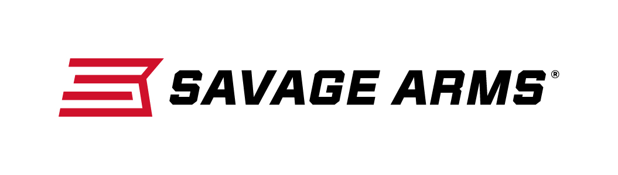
Contact: JJ Reich
Communications Manager
Firearms and Ammunition
(763) 323-3862
FOR IMMEDIATE RELEASE E-mail: pressroom@vistaoutdoor.com

Savage Arms Offers Lineup of 10/110 BA Stealth Precision Rifles

SUFFIELD, Connecticut – October 6, 2016 – Savage Arms is pleased to announce its offering of four bolt-action, long-range, chassis precision rifles—two calibers in short-action and two calibers in long-action. The new Model 10/110 BA Stealth is a lighter, more compact offering in the BA line and is available in 308 Win., 6.5 Creedmoor, 300 Win Mag and 338 Lapua. Shipments of these new rifles are currently being delivered to dealers.

Savage teamed with Drake Associates to expand this “BA” line of long-range chassis rifles. The new Model 10/110 BA Stealth features a factory-blueprinted Model 10/110 barreled action mated to a custom version of the Drake Hunter/Stalker monolithic chassis, which has been enhanced to Savage’s specifications. A similar Savage/Drake combination recently took first place for a National Guard Team and 8th place overall at the 2015 U.S. Army International Sniper Competition.

General Features & Benefits
- Factory-blueprinted Savage action
- Monolithic chassis machined from a solid billet of aluminum
- M-LOK forend and Picatinny rail for easy configuration
- Adjustable AccuTrigger

Specific Features & Benefits for 10 BA Stealth (short action)
- 5/8 x 24 threaded muzzle with protector
- EGW one-piece scope rail
- Fab Defense GL-SHOCK six-position, shock-absorbing buttstock with adjustable cheek

Specific Features & Benefits for 110 BA Stealth (long action)
- 5/8 24 threaded muzzle with brake
- Drake one-piece long scope rail
- Fab Defense GLR-16 six-position buttstock with adjustable cheek riser

Part No. / Description / MSRP
22637 / 10 BA Stealth, 308 Win. / $1207
22638 / 10 BA Stealth, 6.5 Creedmoor / $1207
22639 / 110 BA Stealth, 300 Win. Mag. / $1484
22640 / 110 BA Stealth, 338 Lapua Mag. / $1622

Savage Arms is a brand of Vista Outdoor Inc., an outdoor sports and recreation company. To learn more about Savage Arms, visit www.savagearms.com.

About Vista Outdoor Inc.
Vista Outdoor is a leading global designer, manufacturer and marketer of consumer products in the growing outdoor sports and recreation markets. The company operates in two segments, Shooting Sports and Outdoor Products, and has a portfolio of well-recognized brands that provides consumers with a wide range of performance-driven, high-quality and innovative products for individual outdoor recreational pursuits. Vista Outdoor products are sold at leading retailers and distributors across North America and worldwide. Vista Outdoor is headquartered in Utah and has manufacturing operations and facilities in 13 U.S. States, Canada, Mexico and Puerto Rico along with international customer service, sales and sourcing operations in Asia, Australia, Canada, Europe and New Zealand. For news and information, visit www.vistaoutdoor.com or follow us on Twitter @VistaOutdoorInc and Facebook at www.facebook.com/vistaoutdoor.

###

