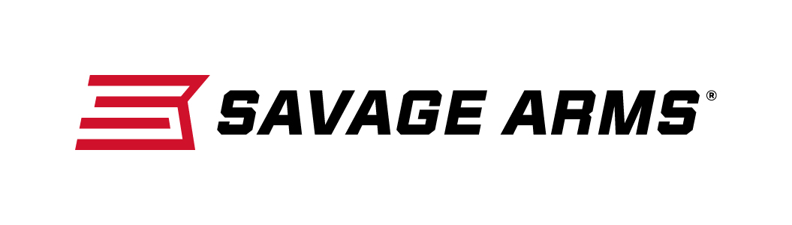
Contact: JJ Reich
Communications Manager
Firearms and Ammunition
(763) 323-3862
FOR IMMEDIATE RELEASE E-mail: pressroom@vistaoutdoor.com

“Savage & Federal Centerfire Promotion” Rebate Program Going Strong

ANOKA, Minn. – September 6, 2016 – Federal Premium Ammunition and Savage Arms have teamed up to offer hunters and shooters a can’t-miss deal. Through the ‘Federal & Savage Centerfire Promotion,’ customers who purchase $50 of qualifying Federal Premium, Federal Power-Shok or Fusion ammunition and a new Savage centerfire rifle will get $25 back by a mail-in rebate.

“Federal Premium, Federal Power-Shok and Fusion all have a strong reputation for delivering ideal performance for a large variety of game,” said Federal Premium Marketing Director Jason Nash. “This rebate is a great way to win over new shooters looking to buy their first box of our ammo, or reward our dedicated customer base with significant cash-back rebate for continuing to shoot our loads.”

“We are excited to be a part of this promotion,” said Savage Arms Marketing Director Bill Dermody. “It’s a chance to partner time-tested, field-proven products and put them into the hands of hunters and shooters across the country, which will definitely help them be more successful. We are honored to partner with Federal Premium to provide customers a great value on top-quality products that benefit both beginner and hardcore shooting enthusiasts.”

Purchases must be made between August 12, 2016 and December 31, 2016. Consumer must purchase ammunition and firearm within 30 days of each other. Rebate coupon must be postmarked by January 31, 2017.

For full details on the program and to download the rebate coupon, visit www.federalpremium.com/news/promotions_rebates.aspx.

Federal Premium and Savage Arms are brands of Vista Outdoor Inc., an outdoor sports and recreation company. For more information on these brands, go to www.federalpremium.com and www.savagearms.com.

About Vista Outdoor Inc.
Vista Outdoor is a leading global designer, manufacturer and marketer of consumer products in the growing outdoor sports and recreation markets. The company operates in two segments, Shooting Sports and Outdoor Products, and has a portfolio of well-recognized brands that provides consumers with a wide range of performance-driven, high-quality and innovative products for individual outdoor recreational pursuits. Vista Outdoor products are sold at leading retailers and distributors across North America and worldwide. Vista Outdoor is headquartered in Utah and has manufacturing operations and facilities in 13 U.S. States, Canada, Mexico and Puerto Rico along with international customer service, sales and sourcing operations in Asia, Australia, Canada, Europe and New Zealand. For news and information, visit www.vistaoutdoor.com or follow us on Twitter @VistaOutdoorInc and Facebook at www.facebook.com/vistaoutdoor.

###

