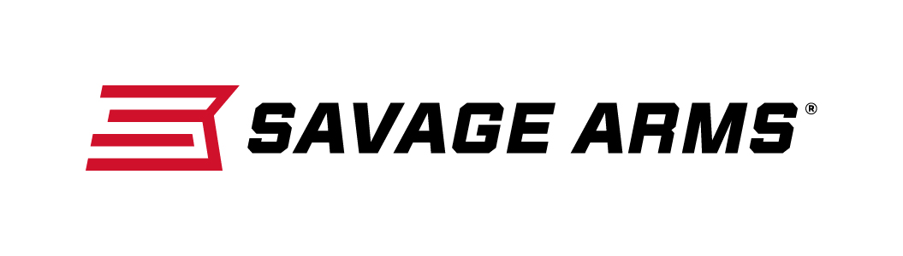
Contact: JJ Reich
Communications Manager
Firearms and Ammunition
(763) 323-3862
FOR IMMEDIATE RELEASE E-mail: pressroom@vistaoutdoor.com

“Save on a Savage” Rebate Promotion Going Strong

SUFFIELD, Conn. – August 31, 2016 – Hunters and shooters can now get the accuracy and dependability they trust from Savage Arms at an even more affordable price. The “Save on a Savage” rebate program offers customers the opportunity to choose from dozens of firearms and receive cash back.

“This isn’t a small promotion. The list of firearms that qualify for this promotion is quite impressive—several of both centerfire and rimfire rifle styles are eligible,” said Savage Firearms Marketing Director Bill Dermody. “This program also includes the popular A17 17 HMR which was voted ‘Rifle of the Year by both NRA American Hunter and Guns & Ammo magazines.”

The rebate offers include buying any Savage Arms Trophy Hunter, DOA Hunter, Model 14/114 or Model 16/116 and receive a $75 mail-in rebate; or choose any AXIS or A17 synthetic stock and get $30 back. Shooters who purchase any bolt-action Savage rimfire, including the B.MAG and Rascal, will be eligible for a $25 mail-in rebate.

“Savage Arms has a strong reputation for delivering quality, accurate rifles at surprisingly low retail prices. It’s the key to the popularity of our products, and it’s why we have so many dedicated repeat customers,” said Dermody. “This rebate is a great way to win over new shooters looking to buy their first Savage rifle. It also gives our many loyal customers a great opportunity to add another Savage to their collection.”

Firearms must be purchased between Aug. 11, 2016 and September 25, 2016. Rebate coupon must be received by October 25, 2016. Offer valid in U.S. and Canada; U.S. funds only.

For full details on the program and to download the rebate coupon, visit http://www.savagearms.com/promotions/.

Savage Arms is a brand of Vista Outdoor Inc., an outdoor sports and recreation company. To learn more about Savage Arms, visit www.savagearms.com.

About Vista Outdoor Inc.
Vista Outdoor is a leading global designer, manufacturer and marketer of consumer products in the growing outdoor sports and recreation markets. The company operates in two segments, Shooting Sports and Outdoor Products, and has a portfolio of well-recognized brands that provides consumers with a wide range of performance-driven, high-quality and innovative products for individual outdoor recreational pursuits. Vista Outdoor products are sold at leading retailers and distributors across North America and worldwide. Vista Outdoor is headquartered in Utah and has manufacturing operations and facilities in 13 U.S. States, Canada, Mexico and Puerto Rico along with international customer service, sales and sourcing operations in Asia, Australia, Canada, Europe and New Zealand. For news and information, visit www.vistaoutdoor.com or follow us on Twitter @VistaOutdoorInc and Facebook at www.facebook.com/vistaoutdoor.

###

