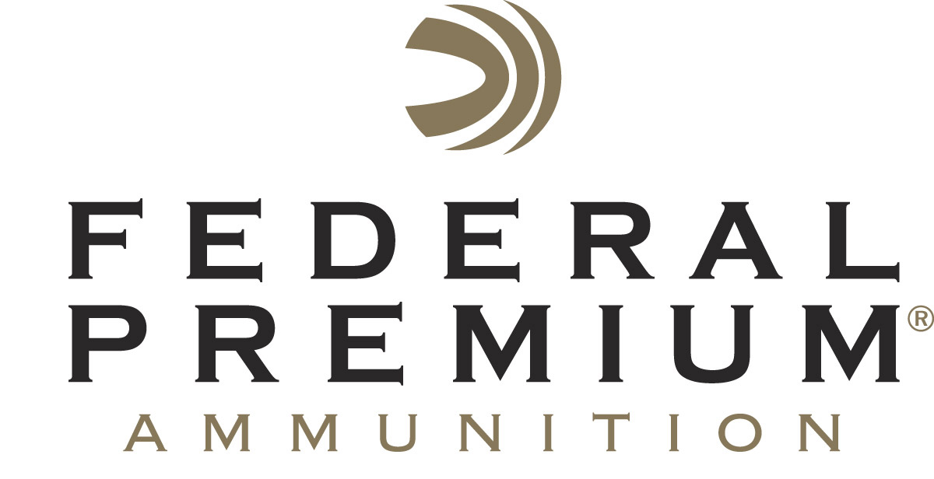
Contact: JJ Reich
Communications Manager
Firearms and Ammunition
(763) 323-3862
FOR IMMEDIATE RELEASE E-mail: pressroom@vistaoutdoor.com

Federal Premium Announces 2017 Bill Stevens 4-H Leadership Award

ANOKA, Minnesota – July 12, 2017 – Federal Premium Ammunition recently announced the recipient of the seventh annual Bill Stevens 4-H Leadership Award.
Mr. Steve Pritchard from Nebraska was recently honored with the award.

In 2011, Federal Premium Ammunition created an award to honor those volunteers and professionals involved in the 4-H Shooting Sports Project who have gone the extra mile to achieve the mission of 4-H Shooting Sports.

The award is named after the late Bill Stevens, Federal’s former Conservation Programs Manager who retired in 2007 after 42 years. Stevens played a major role in making the shooting sports a part of 4-H across the nation. He also increased Federal’s support of the 4-H program.

Pritchard was selected for the award partly because of his service as state coordinator for the 4-H Shooting Sports program for more than 15 years, as well as many other positive contributions to the organization throughout 2017 and prior. Under his guidance and dedication, the shooting sports program in Nebraska has an all-time high enrollment of almost 5,000 youth. Plus, he has also trained nearly 1,000 adult volunteers over the years of his enthusiastic involvement. These are just a few examples of the good that Prichard delivers to the overall 4-H program.

Federal Premium Ammunition has sponsored 4-H conservation and shooting sports programs for more than 80 years. In addition to sponsoring national competitions, the company was integral in both the formation of 4-H conservation-themed camps in 1934 and the Shooting Sports Project in 1976.

4-H Shooting Sports reached over 400,000 children in 2016. Federal Premium has donated more than $440,000 to 4-H Shooting Sports in the last decade, and its lifetime support totals more than $1.2 million.

“Youth development through the shooting sports has been a mission we have shared with 4-H for decades. Professional educators like Steve are helping to create young citizens that will be tomorrow’s leaders,” said Ryan Bronson, Director of Conservation for Federal Premium Ammunition. “Pritchard is an outstanding example of a great teacher, mentor and role model. He is well deserving of this award, and we congratulate him.”

To learn more about 4-H Shooting Sports visit www.4-hshootingsports.org.

Federal Premium is a brand of Vista Outdoor Inc., an outdoor sports and recreation company. For more information on Federal Premium, go to www.federalpremium.com.

About Vista Outdoor
Vista Outdoor is a leading global designer, manufacturer and marketer of consumer products in the growing outdoor sports and recreation markets. The company operates in two segments, Shooting Sports and Outdoor Products, and has a portfolio of well-recognized brands that provides consumers with a wide range of performance-driven, high-quality and innovative products for individual outdoor recreational pursuits. Vista Outdoor products are sold at leading retailers and distributors across North America and worldwide. Vista Outdoor is headquartered in Utah and has manufacturing operations and facilities in 13 U.S. States, Canada, Mexico and Puerto Rico along with international customer service, sales and sourcing operations in Asia, Australia, Canada, and Europe. For news and information, visit www.vistaoutdoor.com or follow us on Twitter @VistaOutdoorInc and Facebook at www.facebook.com/vistaoutdoor.

###

