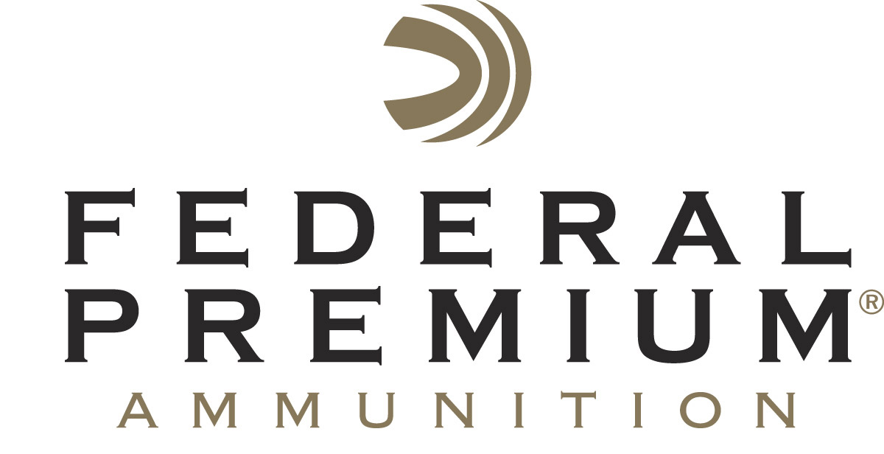
Contact: JJ Reich
Communications Manager
Firearms and Ammunition
(763) 323-3862
FOR IMMEDIATE RELEASE E-mail: pressroom@vistaoutdoor.com

Federal Premium Signs On as Major Sponsor
of U.S. Practical Shooting Association

ANOKA, Minnesota – August 31, 2017 – Federal Premium Ammunition is pleased to announce its sponsorship of the United States Practical Shooting Association (USPSA). The alliance supports the organization’s tireless stewardship of competitive practical shooting, along with the matches, new shooter recruitment efforts and other activities of more than 445 affiliated local clubs and 30,000 USPSA members nationwide.

“We’re proud to be the first major ammunition manufacturer to enter this exciting arena,” said Federal Premium Product Line Manager Justin Johnson. “USPSA shooters demand very specific things from their ammunition. It needs to be accurate, consistent, reliable, and meet power factor requirements. Until our launch of Syntech Action Pistol, reloading was the preferred way to achieve all of the above. With our factory-loaded ammunition, shooters have a simple, convenient and better solution.”

Johnson noted that the USPSA partnership greatly increases Federal Premium backing of this sport through event and shooter sponsorships. “USPSA is a huge piece of the target shooting market,” he said. “This is a monumental leap forward for both organizations, and we are excited to be on the ground floor for continued greatness to come.”

Founded in 1984, USPSA is the national governing body of competitive practical shooting in the United States under the International Practical Shooting Confederation. The USPSA provides a wide range of challenging competitive opportunities that pit participants against shooters of similar skill levels in distinct divisions geared to various handguns, rifles, and shotguns. The association welcomes new shooters of all ages and abilities, and offers club matches, including Steel Challenge events all over the country.

"This revolutionary opportunity creates a lower barrier to entry for new shooters to participate in the shooting sports, while giving existing USPSA shooters alternatives to reloading and sourcing match ammunition,” said Mike Foley, President and CEO of U.S. Practical Shooting Association. “The power factor requirements for multiple USPSA divisions can be met with ammunition available from retailers instead of custom loads requiring a larger investments in time and equipment. USPSA will gain market recognition in mainstream sporting goods stores, and this relationship provides additional funding for education and event promotion. To say the least, we are extremely excited to be working with Federal Premium Ammunition."

New American Eagle Syntech Action Pistol is specifically designed for the action shooting sports and loaded to power factor requirements with heavy, flat-nose bullets for more reliable knock-downs on steel targets. Like all Syntech loads, Action Pistol rounds also feature the exclusive Total Synthetic Jacket (TSJ), which prevents metal-on-metal contact between the bullet and barrel, eliminating copper and lead fouling as well as reducing damaging heat and friction.

Combined with clean-burning powder and the Catalyst lead-free primer, Syntech Action Pistol provides the softest-shooting, most reliable performance possible for high-volume competitive shooters. Full details will be released in January 2018 during the SHOT Show timeframe.

Federal Premium is a brand of Vista Outdoor Inc., an outdoor sports and recreation company. For more information on Federal Premium, go to www.federalpremium.com.

About Vista Outdoor
Vista Outdoor is a leading global designer, manufacturer and marketer of consumer products in the growing outdoor sports and recreation markets. The company operates in two segments, Shooting Sports and Outdoor Products, and has a portfolio of well-recognized brands that provides consumers with a wide range of performance-driven, high-quality and innovative products for individual outdoor recreational pursuits. Vista Outdoor products are sold at leading retailers and distributors across North America and worldwide. Vista Outdoor is headquartered in Utah and has manufacturing operations and facilities in 13 U.S. States, Canada, Mexico and Puerto Rico along with international customer service, sales and sourcing operations in Asia, Australia, Canada, and Europe. For news and information, visit www.vistaoutdoor.com or follow us on Twitter @VistaOutdoorInc and Facebook at www.facebook.com/vistaoutdoor.

###

