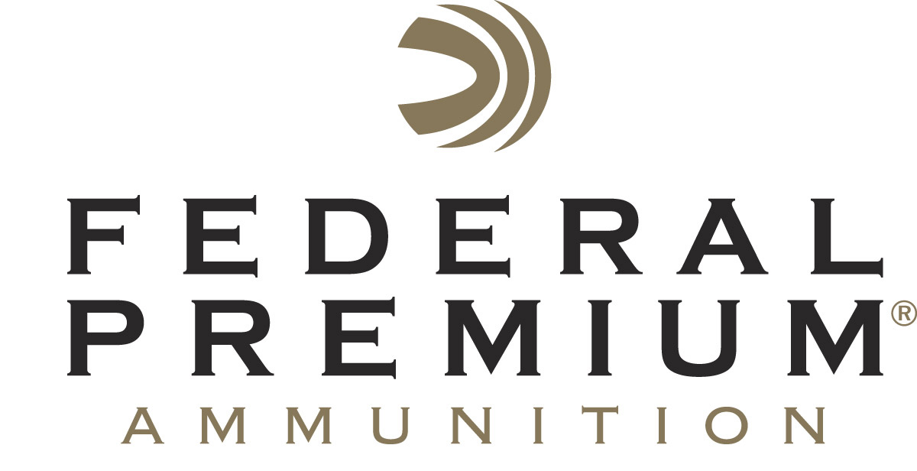
Contact: JJ Reich
Communications Manager
Firearms and Ammunition
(763) 323-3862
FOR IMMEDIATE RELEASE E-mail: pressroom@vistaoutdoor.com

Proven Gold Medal Rifle Ammunition Delivers Out-Of-The-Box Accuracy for Precision Rifle Competitors

ANOKA, Minnesota – August 8, 2017 – Federal Premium Gold Medal rifle ammunition has a decades-long track record for reliable and consistent accuracy straight out of the box. Precision Rifle Series participants and other competitive shooters continue to rely on these factory loads to win.

Recently, Federal Premium brand ambassador Patrick E. Kelley used an out-of-the-box Savage MSR 10 fueled with factory-loaded Gold Medal 308 Win. 175-grain Sierra MatchKing (GM308M2) to finish 10th overall at the MGM Targets Ironman Long Range Challenge, held July 8 and 9 in Parma, Idaho. Kelley also took 2nd place in the event’s Tactical Heavy Division, part of the Precision Rifle Series (PRS) Gas Gun Points Competitions.

“Kelley came to the event as a first-time competitor in this type of match, equipped with a factory-built Savage and Federal Premium ammunition—no custom rifle or special handloads,” said Federal Premium Centerfire Rifle Ammunition Product Line Manager Justin Johnson. “To finish so well with factory equipment is unheard of. His ability to use equipment any person can get right off the shelves of a local gun shop is a true testament to our products.”

Gold Medal rifle loads provide the best primer sensitivity and most consistent ballistics in the industry. The precision-built Sierra MatchKing bullet’s boat-tail hollow-point design provides the extra margin of performance shooters need, and its uniform match jacket ensures consistent, long-range accuracy. The loads also tout Federal brass, specially formulated propellant and benchrest-quality Gold Medal primers.

“With this being my very first venture into to the PRS scene, it was especially important to assemble the best equipment I could. Federal Premium’s Gold Medal was the foundation for the assembly,” said Kelley. "It allowed me to hit steel targets from 16 yards to over 750 yards away, from some very challenging positions.

“Going into this match as a 3-gun competition shooter with next to no experience at long range, nor Precision Rifle Series events, I knew my equipment had to perform,” continued Kelley. “Federal Premium proved to be exactly what I needed to finish strong, and it is what I will continue to rely on.”

Federal Premium is a brand of Vista Outdoor Inc., an outdoor sports and recreation company. For more information on Federal Premium, go to www.federalpremium.com.

About Vista Outdoor
Vista Outdoor is a leading global designer, manufacturer and marketer of consumer products in the growing outdoor sports and recreation markets. The company operates in two segments, Shooting Sports and Outdoor Products, and has a portfolio of well-recognized brands that provides consumers with a wide range of performance-driven, high-quality and innovative products for individual outdoor recreational pursuits. Vista Outdoor products are sold at leading retailers and distributors across North America and worldwide. Vista Outdoor is headquartered in Utah and has manufacturing operations and facilities in 13 U.S. States, Canada, Mexico and Puerto Rico along with international customer service, sales and sourcing operations in Asia, Australia, Canada, and Europe. For news and information, visit www.vistaoutdoor.com or follow us on Twitter @VistaOutdoorInc and Facebook at www.facebook.com/vistaoutdoor.

###

